Science 7
Unit A
Project
Researching a Species at Risk

You are required to submit this project to your teacher for marks. Very carefully, read the project task and how to do it. Be sure to read the rubric, which explains the expectations for this project.

Situation

The Government of Canada has a list of species at risk. You can find these species at http://www.registrelep-sararegistry.gc.ca. These include species that are extirpated, endangered, or threatened, as well as those of special concern. If you do not remember the meanings of these terms, review lesson A12.

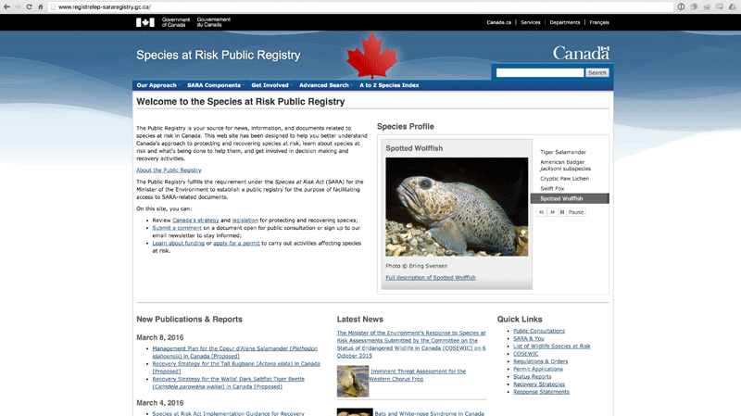

Project Task

You are expected to learn as much as you can about one species at risk in Canada. As you learn about the species, focus on its population status. What is happening to its population in Canada? Why is it at risk? Be prepared to do separate searches online for your answers. Then, you will produce an action plan to protect this species and its ecosystem.

When you have chosen a species but before you begin your research, ask yourself these questions:

- How is this species important to its ecosystem? What ecological roles does it have? (Review Lessons A3 and A4.)
- What human activities put this species at risk? (Review Lesson A11.)
- Which of this species’ needs are not being met? (Review Lesson A2.)
- What can humans do to restore the means to meet those needs? (Review Lesson A14.)

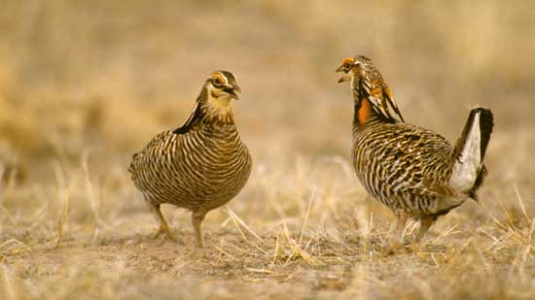

Method

- First, build an ecological profile of your chosen species:

- Start a word document. Include the following categories:

  - Description of the species (What is the organism’s size and other features? Where does it live? Include a photo or drawing if possible.)
  - Description of habitat (Where does it live, feed, and reproduce? What does this ecosystem look like?)
  - Food web and relationships with other species (How does the species fit into its food chain and food web? Focus on what it eats and who eats it. Build a simple food web that incorporates the species. How is the species important to its food web?)

2. Build an action plan to protect the species.

- Describe how the species is at risk. Is it extirpated, endangered, threatened, or of special concern? Is it threatened by habitat loss, habitat destruction (such as loss of water source, pollution of water, air, or soil, loss of breeding sites), overhunting, climate change, or invasive species? How many threats is it facing at the same time?

- Protection plan – ways the threats can be reversed. How can the species ecosystem be restored? Does it require the protection or restoration of a specific habitat? Could more be done to protect it? How does its protection benefit humans?

Rubric

This rubric explains how your project will be marked. It explains everything you must include in your assessment. Read it very carefully before you start your work.

Researching a Species at Risk
24 marks

CRITERIA | PERFORMANCE
CRITERIA |  | NOT OK | OK | GOOD | EXCELLENT
CRITERIA | Not Submitted  0 marks | Does not meet criteria  1 mark | Minimally meets criteria  2 marks | Fully meets criteria  3 marks | Exceeds  criteria  4 marks
Description of species | Not  Submitted | No description of species | Description is too brief and lacks detail | Full basic description of species provided | Full description of species provided with great detail
Description of species habitat | Not  Submitted | No habitat described | Habitat described only briefly | Habitat described, including food sources and living space | Habitat described in great detail, including how well it meets needs of the species
Species food web | Not  Submitted | No description of how the species fits into a food chain or food web | Description of simple food chain for the species | Description of simple food web and food chain | Description of food chain plus branched food web indicating how the species is part of the energy flow of the ecosystem
Understanding of why the species is listed as at risk | Not  Submitted | No discussion of why species is listed at risk | Very brief explanation of why the species is at risk | Basic description of why it is at risk | A very detailed description of why the species is at risk
Description of a protection plan | Not  Submitted | No protection plan described | Protection plan very briefly described | Basic protection plan described | Very detailed protection plan described
Communication | Not  Submitted | Species profile and protection plan not communicated clearly; details lacking | Species profile and protection plan partly communicated; some details lacking or confusing | Species profile and protection plan communicated, but descriptions brief | Species profile and protection plan communicated with great detail and clarity

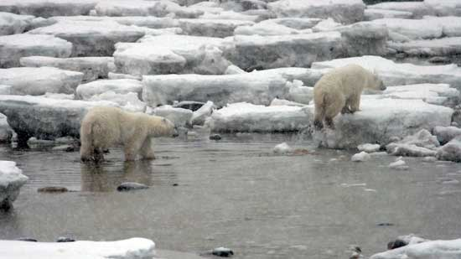

Submitting Your Work

If you do this project as pencil drawing(s) on another piece of paper, you will have to scan your work to submit it.

If you have prepared any other electronic images or documents for this project, you will need to submit them. The same goes for any Internet location where your work is located, you will need to submit the URL so your teacher can view your work.

When you are ready to submit your completed task, return to the project page in your online course and click the “Add submission” button at the bottom of the page and follow the directions.

Note that when you submit anything to your teacher, PLEASE INCLUDE YOUR NAME IN THE DOCUMENT TITLE. For example, you might title it something like this:

UnitA_Project_Jenny_Smith.doc

