Science 7
Unit B
Pre-assessment Quiz

Answer all 4 questions in the spaces provided. Think carefully before typing your answers. Save your quiz when you are done.

Leave your answers in blue; it will be easier for you see them later. If you choose to send this to your teacher, it will be easier for them to see your answers as well.

Question 1

Which plant will survive the best in a very dry climate, aloe (left) or ivy (right)? Why?

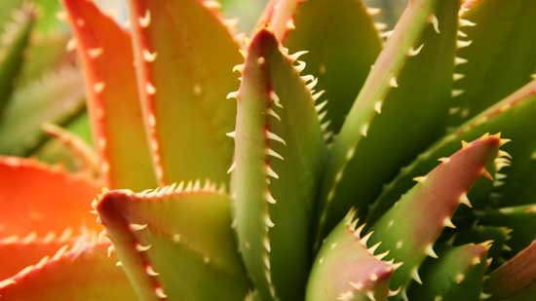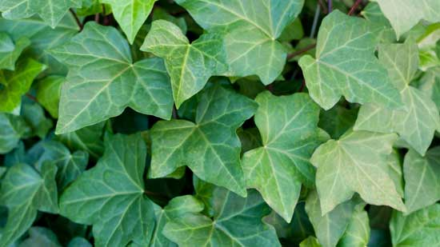

Type your answer here.

Question 2

What are two things that plants need to stay alive?

Type your answer here.

Question 3

What are three plants that you use almost everyday?

Type your answer here.

Question 4

What is one thing that farmers do to help them grow more crops?

Type your answer here.

