Science 7
Unit B
Lesson 2
Self-Check Quiz

Answer all 5 questions in the spaces provided. Think carefully before typing your answers. If you need help, return to the lesson in the online course. Save your quiz when you are done.

Leave your answers in blue; it will be easier for you and your teacher to see them later.

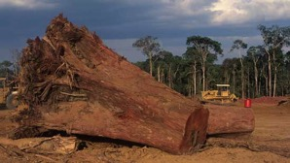
Question 1

In Brazil, many rainforests are being cut to clear land for cattle ranching. How does cutting trees affect climate in Brazil?

Type your answer here.

Question 2

Why is maple syrup not collected in the middle of summer?

Type your answer here.

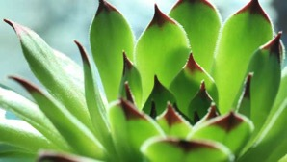
Question 3

Why do plants in dry climates have thick, waxy stems and leaves?

Type your answer here.

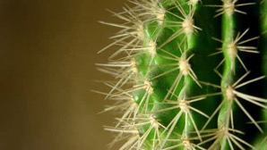
Question 4

Why is having spines instead of leaves an advantage to cactus plants?

Type your answer here.

Question 5

What would you expect to see if you put a celery stalk with leaves into a cup of water with red food colouring?

Type your answer here.

Congratulations! You have completed this self-check quiz.

Now it's time to carefully compare your answers to the suggested answers in the online course. When comparing, you should feel free to make changes to your answers or make extra notes.

Don't forget to save the quiz whenever you make changes.

Keep this quiz for study purposes. If you want more feedback, share it with your teacher.

