Science 7
Unit B
Lesson 3
Self-Check Quiz

Answer all 5 questions in the spaces provided. Think carefully before typing your answers. If you need help, return to the lesson in the online course. Save your quiz when you are done.

Leave your answers in blue; it will be easier for you and your teacher to see them later.

Question 1

A boy bought two houseplants that were the same size. He put one in a bathroom with no window and the other one beside his bedroom window. After six months, the plant in the bedroom was twice as big as the plant in the bathroom. Explain why the bedroom plant was bigger than the bathroom plant was.

Type your answer here.

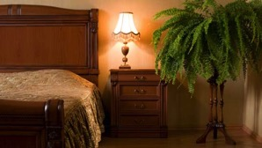
Question 2

A girl had many headaches from sitting in her room with the door and windows closed. She bought a large houseplant to put in her room, and her headaches stopped. Explain the likely reason for the girl’s headaches to stop.

Type your answer here.


Question 3

Why do people add living plants to fish aquariums (other than that they look nice)?

Type your answer here.

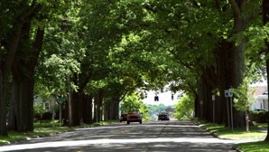
Question 4

Trees are planted beside busy city streets. How do trees improve air quality in a city?

Type your answer here.

Question 5

A scientist measures the levels of carbon dioxide in Banff National Park during a period of 24 hours in July. She finds that at night more carbon dioxide is in the forest air than during the day. What is a good explanation for the scientist’s findings?

Type your answer here.

Congratulations! You have completed this self-check quiz.

Now it's time to carefully compare your answers to the suggested answers in the online course. When comparing, you should feel free to make changes to your answers or make extra notes.

Don't forget to save the quiz whenever you make changes.

Keep this quiz for study purposes. If you want more feedback, share it with your teacher.

