Science 7
Unit B
Lesson 4
Self-Check Quiz

Answer all 5 questions in the spaces provided. Think carefully before typing your answers. If you need help, return to the lesson in the online course. Save your quiz when you are done.

Leave your answers in blue; it will be easier for you and your teacher to see them later.

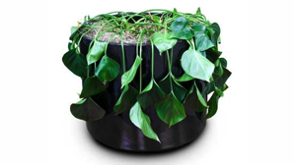
Question 1

If land plants are watered with saltwater, they will wilt and die. Explain why you should never give saltwater to land plants.

Type your answer here.


Question 2

A gardener sprinkles nitrogen fertilizer in the soil around some garden plants. After a few days, the garden plants start growing rapidly. Describe the process that causes nitrogen fertilizer to move inside the plant roots. Use the terms “high concentration” and “low concentration” in your answer.

Type your answer here.

Question 3

How are osmosis and diffusion similar? How are osmosis and diffusion different?

Type your answer here.

Question 4

Why is the cell membrane an important structure in plant cells?

Type your answer here.


Question 5

The plant cells of tree trunks have very thick and sturdy cell walls. The plant cells of grass blades have thinner, more flexible cell walls. What is the best explanation for why these two different types of plants have different types of cell walls?

Type your answer here.

Congratulations! You have completed this self-check quiz.

Now it's time to carefully compare your answers to the suggested answers in the online course. When comparing, you should feel free to make changes to your answers or make extra notes.

Don't forget to save the quiz whenever you make changes.

Keep this quiz for study purposes. If you want more feedback, share it with your teacher.

