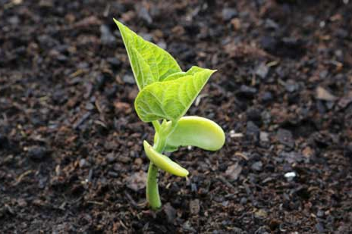
Science 7
Unit B, Lesson 5
Lesson Activity
Sprouting Conditions

Try this experiment to discover the conditions needed to germinate bean seeds.

Materials:
- 8 bean seeds
- 4 small glass jars with lids
- paper towels
- water

Instructions:

Jar 1: Wet seeds in light
- Fold a paper towel and put it in a glass jar.
- Make the paper towel damp with water -- but not soaking wet.
- Put two bean seeds in the jar and close the jar.
- Put the jar near a sunny window.

Jar 2: Dry seeds in light
- Fold a paper towel and put it in a glass jar.
- Do not add water to the jar.
- Put two bean seeds in the jar and close the jar.
- Put the jar near a sunny window.
Jar 3: Wet seeds in dark
- Fold a paper towel and put it in a glass jar.
- Make the paper towel damp with water -- but not soaking wet.
- Put two bean seeds in the jar and close the jar.
- Put this jar in a dark cupboard.
Jar 4: Dry seeds in dark
- Fold a paper towel and put it in a glass jar.
- Do not add water to the jar.
- Put two bean seeds in the jar and close the jar.
- Put this jar in a dark cupboard.

Hypothesis:

Which jar of bean seeds will germinate the fastest? Why?

Which jar of bean seeds will germinate the slowest? Why?

Observations:

- Once a day for one week, add a little water to the wet paper towels to keep them from drying.

- Observe and draw a picture of the bean seeds in the four jars each day for one week. Use a chart such as the following to record your observations:

Day | Jar 1:  Wet seeds in light | Jar 2:  Dry seeds in light | Jar 3:  Wet seeds in dark | Jar 4:  Dry seeds in dark
1
2
3
4
5
6
7

Questions:

Think about the following questions very carefully. Then, type answers in the space provided. When you have your answers, click the questions in the online course for feedback.

- What differences did you notice between the bean seeds germinated in wet conditions and the bean seeds germinated in dry conditions?

- What differences did you notice between the bean seeds germinated in the light and the bean seeds germinated in the dark?

- What conclusion can you make about the best conditions for bean seeds to germinate?

