Science 7
Unit B
Lesson 5
Self-Check Quiz

Answer all 5 questions in the spaces provided. Think carefully before typing your answers. If you need help, return to the lesson in the online course. Save your quiz when you are done.

Leave your answers in blue; it will be easier for you and your teacher to see them later.

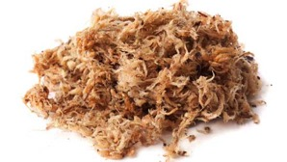
Question 1

Seed-starting soil often contains peat moss, which absorbs water well. Why is peat moss used to start seeds?

Type your answer here.

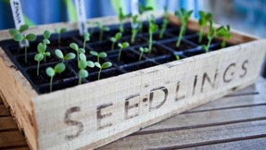
Question 2

In March, Alberta gardeners start flower and vegetable seedlings indoors. By late April, gardeners put seedlings outside for a few hours each day. This is called “hardening off”. Why is hardening off important for seedlings?

Type your answer here.

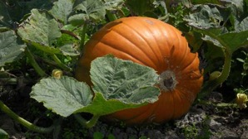
Question 3

Pumpkin seed packets recommend that pumpkin seeds be planted at least 2 metres from any other plant. Why?

Type your answer here.

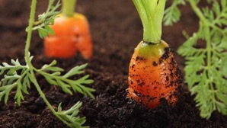
Question 4

A gardener plants carrot seeds. After the seedlings have sprouted, he “thins them” by removing some of the seedlings. Why does the gardener do this?

Type your answer here.

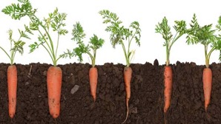
Question 5

Before planting root vegetables in the spring, digging the garden dirt to a depth of at least 30 centimetres is important. Why?

Type your answer here.

Congratulations! You have completed this self-check quiz.

Now it's time to carefully compare your answers to the suggested answers in the online course. When comparing, you should feel free to make changes to your answers or make extra notes.

Don't forget to save the quiz whenever you make changes.

Keep this quiz for study purposes. If you want more feedback, share it with your teacher.

