Science 7
Unit B
Lesson 6
Self-Check Quiz

Answer all 5 questions in the spaces provided. Think carefully before typing your answers. If you need help, return to the lesson in the online course. Save your quiz when you are done.

Leave your answers in blue; it will be easier for you and your teacher to see them later.

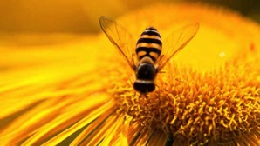
Question 1

Without bees, humans would have a harder time growing food. Explain why bees are important for human food production.

Type your answer here.

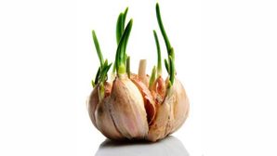
Question 2

If garlic is kept in a warm and bright place, it can start to sprout green stems. Why does garlic sprout green stems?

Type your answer here.

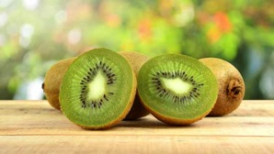
Question 3

Kiwifruit contains tiny black seeds in the middle of a sweet, green, and juicy fruit. Kiwifruit grows wild in China, where it is eaten by monkeys. Explain why the sweet green fruit helps propagate kiwifruit seeds to new areas in China.

Type your answer here.

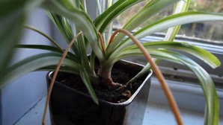
Question 4

Spider plants send out long stems, which grow new little spider plants on the ends. What type of reproduction is this?

Type your answer here.

Question 5

A spring hailstorm breaks all the blossoms off the fruit trees in an orchard. Later that year, the orchard trees don’t produce any fruit. What is the best explanation for this observation?

Type your answer here.

Congratulations! You have completed this self-check quiz.

Now it's time to carefully compare your answers to the suggested answers in the online course. When comparing, you should feel free to make changes to your answers or make extra notes.

Don't forget to save the quiz whenever you make changes.

Keep this quiz for study purposes. If you want more feedback, share it with your teacher.

