Science 7
Unit B
Section 1
Self-Check Quiz

Answer all 5 questions in the spaces provided. Think carefully before typing your answers. If you need help, return to the lesson in the online course. Save your quiz when you are done.

Leave your answers in blue; it will be easier for you and your teacher to see them later.

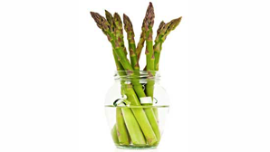
Question 1

The best way to keep asparagus crisp is to cut off the ends and put the asparagus into a container of water in the fridge. How does this help the asparagus stay crisp?

Type your answer here.

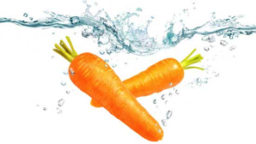
Question 2

If a slightly limp carrot is placed in a bowl of cold water, the carrot will become crisp again. Explain why this happens.

Type your answer here.

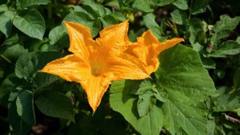
Question 3

A boy planted a pumpkin plant in a greenhouse. The plant grew vines and flowers, but it never produced any pumpkins. What is the best explanation for why the plant did not grow pumpkins?

Type your answer here.

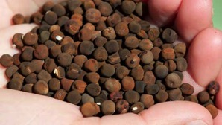
Question 4

A packet of sweet pea flower seeds says that the seeds should be soaked in water for 24 hours before planting. Why should the seeds be soaked before planting?

Type your answer here.

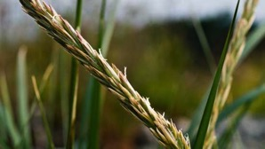
Question 5

Quackgrass is a weed that spreads quickly through gardens. When gardeners dig up quackgrass plants, they find underground webs of white stems. How does quackgrass reproduce?

Type your answer here.

Congratulations! You have completed this self-check quiz.

Now it's time to carefully compare your answers to the suggested answers in the online course. When comparing, you should feel free to make changes to your answers or make extra notes.

Don't forget to save the quiz whenever you make changes.

Keep this quiz for study purposes. If you want more feedback, share it with your teacher.

