Science 7
Unit B
Lesson 7
Self-Check Quiz

Answer all 5 questions in the spaces provided. Think carefully before typing your answers. If you need help, return to the lesson in the online course. Save your quiz when you are done.

Leave your answers in blue; it will be easier for you and your teacher to see them later.

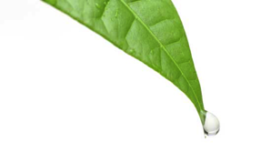
Question 1

Leaves of rainforest plants have very pointy tips. Such a tip is called a “drip tip”.

Why is a drip tip an effective adaptation for a plant in a rainforest?

Type your answer here.

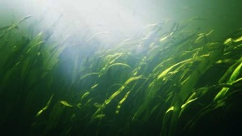
Question 2

Underwater plants have very flexible stems and leaves. If you take these plants out of water, they are floppy.

Why is flexibility an advantage for underwater plants?

Type your answer here.

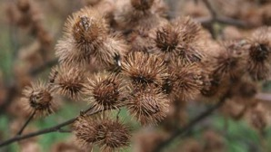
Question 3

Burrs form on certain plants. Burrs are tiny hooks that form around the dry seed of a plant. Burrs can stick to animals that brush past the plant.

How can burrs be an advantage to a plant?

Type your answer here.


Question 4

Prairie crocus flowers bloom in early spring as soon as the snow melts. The flowers and stems of the plant are covered in tiny hairs.

How can the tiny hairs be an effective adaptation for the prairie crocus plant?

Type your answer here.

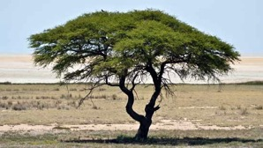
Question 5

Acacia trees grow in the dry savanna grasslands of Africa. Acacia trees have deep taproots that can grow 30 metres (100 feet) into the ground.

Why is a deep taproot an important adaptation for acacia trees?

Type your answer here.

Congratulations! You have completed this self-check quiz.

Now it's time to carefully compare your answers to the suggested answers in the online course. When comparing, you should feel free to make changes to your answers or make extra notes.

Don't forget to save the quiz whenever you make changes.

Keep this quiz for study purposes. If you want more feedback, share it with your teacher.

