Science 7
Unit B
Lesson 8
Self-Check Quiz

Answer all 5 questions in the spaces provided. Think carefully before typing your answers. If you need help, return to the lesson in the online course. Save your quiz when you are done.

Leave your answers in blue; it will be easier for you and your teacher to see them later.

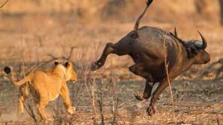
Question 1

Carnivores, such as lions, eat meat. However, plants are still necessary for carnivores to survive. Why?

Type your answer here.

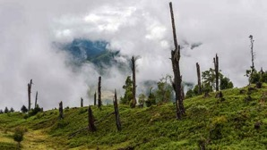
Question 2

The leafy trees in a forest start to die from a disease. Explain two ways that the forest ecosystem is affected.

Type your answer here.

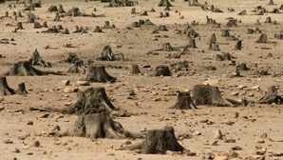
Question 3

Explain one way that cutting down but not replanting trees affects humans negatively.

Type your answer here.


Question 4

If there were no plants, we couldn’t make ice cream. Why?

Type your answer here.

Question 5

Explain two ways that you use plants every day.

Type your answer here.

Congratulations! You have completed this self-check quiz.

Now it's time to carefully compare your answers to the suggested answers in the online course. When comparing, you should feel free to make changes to your answers or make extra notes.

Don't forget to save the quiz whenever you make changes.

Keep this quiz for study purposes. If you want more feedback, share it with your teacher.

