Science 7
Unit B
Lesson 9
Self-Check Quiz

Answer all 5 questions in the spaces provided. Think carefully before typing your answers. If you need help, return to the lesson in the online course. Save your quiz when you are done.

Leave your answers in blue; it will be easier for you and your teacher to see them later.

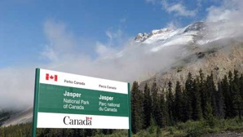
Question 1

Alberta has five national parks located in forests. What is one purpose of such national parks?

Type your answer here.

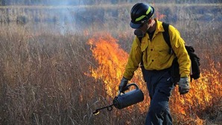
Question 2

What is one advantage of having prescribed fires in forests? What is one risk or disadvantage of having prescribed fires in forests?

Type your answer here.

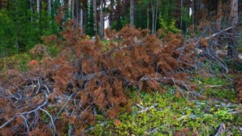
Question 3

How does the mountain pine beetle affect the lumber industry?

Type your answer here.

Question 4

What are two ways that you can help protect forests?

Type your answer here.

Question 5

Why should trees be replanted after clear cutting but not after forest fires?

Type your answer here.

Congratulations! You have completed this self-check quiz.

Now it's time to carefully compare your answers to the suggested answers in the online course. When comparing, you should feel free to make changes to your answers or make extra notes.

Don't forget to save the quiz whenever you make changes.

Keep this quiz for study purposes. If you want more feedback, share it with your teacher.

