Science 7
Unit B
Section 2
Self-Check Quiz

Answer all 5 questions in the spaces provided. Think carefully before typing your answers. If you need help, return to the lesson in the online course. Save your quiz when you are done.

Leave your answers in blue; it will be easier for you and your teacher to see them later.


Question 1

The stems of rose bushes have sharp thorns. How does this adaptation help the rose plant?

Type your answer here.

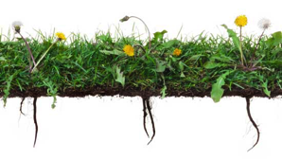
Question 2

Dandelions have very deep taproots. How does this adaptation help dandelion plants?

Type your answer here.

Question 3

What are two ways that people depend on plants to survive?

Type your answer here.

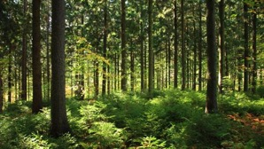
Question 4

What does sustainable forestry mean?

Type your answer here.

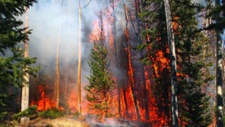
Question 5

Why are forest fires good for some plants?

Type your answer here.

Congratulations! You have completed this self-check quiz.

Now it's time to carefully compare your answers to the suggested answers in the online course. When comparing, you should feel free to make changes to your answers or make extra notes.

Don't forget to save the quiz whenever you make changes.

Keep this quiz for study purposes. If you want more feedback, share it with your teacher.

