Science 7
Unit B
Lesson 11
Self-Check Quiz

Answer all 5 questions in the spaces provided. Think carefully before typing your answers. If you need help, return to the lesson in the online course. Save your quiz when you are done.

Leave your answers in blue; it will be easier for you and your teacher to see them later.

Question 1

What is an advantage of using chemical fertilizers made from ammonia and potash?

Type your answer here.

Question 2

What is a disadvantage of using chemical fertilizers made from ammonia and potash?

Type your answer here.

Question 3

A man draws a map of his backyard garden every year. When he plants his garden every spring, he looks at his garden map from the previous year and plants vegetables in different places than he did the previous year. How does this help the man’s garden?

Type your answer here.

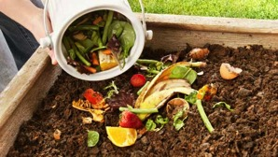
Question 4

What are two important things to remember when making compost?

Type your answer here.

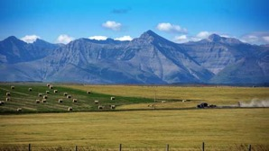
Question 5

Southern Alberta is very dry during the summer. However, lots of crops such as wheat, canola, and corn grow in southern Alberta. What helps crops to grow in this dry climate?

Type your answer here.

Congratulations! You have completed this self-check quiz.

Now it's time to carefully compare your answers to the suggested answers in the online course. When comparing, you should feel free to make changes to your answers or make extra notes.

Don't forget to save the quiz whenever you make changes.

Keep this quiz for study purposes. If you want more feedback, share it with your teacher.

