Science 7
Unit B
Section 3
Self-Check Quiz

Answer all 5 questions in the spaces provided. Think carefully before typing your answers. If you need help, return to the lesson in the online course. Save your quiz when you are done.

Leave your answers in blue; it will be easier for you and your teacher to see them later.

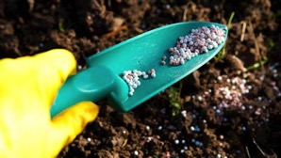
Question 1

Why are fertilizers important for agriculture?

Type your answer here.

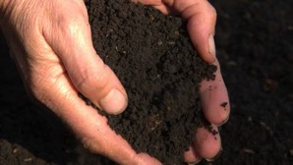
Question 2

Why is loam good for growing most types of plants?

Type your answer here.

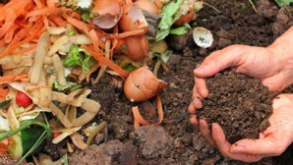
Question 3

What is one advantage of using compost instead of chemical fertilizer in a backyard garden?

Type your answer here.

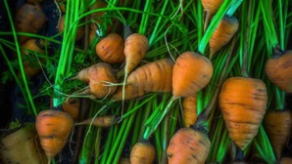
Question 4

The carrots in a garden are very short and stubby.

What does this tell about the type of soil in this garden?

Type your answer here.

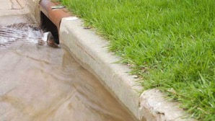
Question 5

In a city, right after a heavy rainstorm in the spring, algae start growing near the storm sewer outlets in one of the city’s rivers.

What is the likely cause of increased algae growth?

Type your answer here.

Congratulations! You have completed this self-check quiz.

Now it's time to carefully compare your answers to the suggested answers in the online course. When comparing, you should feel free to make changes to your answers or make extra notes.

Don't forget to save the quiz whenever you make changes.

Keep this quiz for study purposes. If you want more feedback, share it with your teacher.

