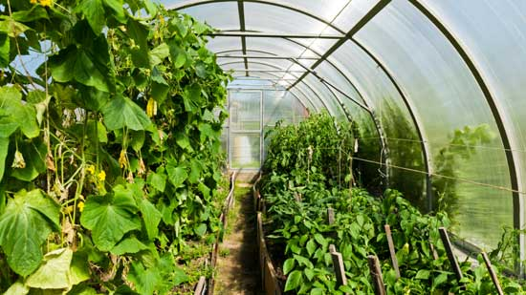
Science 7
Unit B:, Lesson 12
Lesson Activity
Greenhouse Growth

Do greenhouses help plants to grow faster? Try this experiment to find the answer.

In this experiment, you will measure the height of two plants over time. One plant will be in a greenhouse, and the other plant will be open (without the protection of a greenhouse). You will try to keep the amounts of soil, water, and light the same to make the experiment fair.

Quick Question:

This experiment has manipulated, responding, and controlled variables. Do you know which is which?

This experiment is interested in how fast plants grow under certain conditions. The growth of the plants (their height) is the responding variable. One thing has been manipulated or changed in this experiment - whether the plant is in a greenhouse. That is the manipulated variable. We can keep control variables the same to be sure the experiment is fair. This experiment has several control variables: the amount of soil, the amount of light, the temperature, and the type of plant used.

Materials:

- potting soil
- perlite
- large bowl
- 2 plastic cups
- glass or metal pan or tray
- empty 2 L plastic pop bottle
- scissors
- water
- measuring cups
- measuring spoons
- ruler
- bean seeds

Instructions:

- With the scissors, poke a hole into the bottom of each plastic cup.

- Cut the spout off the 2 L plastic pop bottle. (Cut far enough down the slope of the neck so the opening of the bottle can fit over the plastic cup.)

- In the large bowl, mix 4 cups of potting soil and 2 cups of perlite.

- Use a measuring cup to measure the same amount of soil into each plastic cup. (The cups must have the same amounts of the mixture of potting soil and perlite.)

- Over a sink, add 1/8 cup of water to each plastic cup. (Pour very slowly to avoid spills.)

- Into each cup, place 1 bean seed about 1 cm into the soil mixture, covering the seed.
- Put both plastic cups on the pan or tray.

- Place the pop bottle over one of the plastic cups. The pop bottle will act as a greenhouse.

- Put the plants in their tray in a sunny window.

- At the same time every day for 20 days, add 1 tablespoon of water to each plant. (Be exact. This is a science experiment!)

Hypothesis:

Write what you think will happen in this experiment.

- Which bean seed will grow the fastest? Why?
- Which bean seed will grow the slowest? Why?

Observations:

- After you add water to the plants each day, measure the height of each plant stem. (Measure from the soil to the top of the stem.)

- Observe the appearance of each plant.

- Record the height measurements and your observations in a chart such as the one below:

Plant Observations:

Day | Open Plant Height (cm) | Open Plant Appearance | Greenhouse Plant Height (cm) | Greenhouse Plant Appearance
1
2
3
4
5
6
7
8
9
10
11
12
13
14
15
16
17
18
19
20

Questions:

Think about the following questions very carefully. Refer to the height measurements and observations of the bean seeds you recorded. Then, type or write your answers in the space provided. When you have your answers, click the questions in the online course for feedback.

- What differences did you notice between the appearance and growth of the bean seeds grown in a greenhouse and the appearance and growth of the bean seeds grown in the open?

- What conclusion can you make about the best conditions for bean seeds to grow?

