Science 7
Unit B
Lesson 12
Self-Check Quiz

Answer all 5 questions in the spaces provided. Think carefully before typing your answers. If you need help, return to the lesson in the online course. Save your quiz when you are done.

Leave your answers in blue; it will be easier for you and your teacher to see them later.

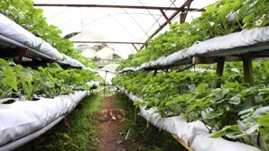
Question 1

What is the advantage of using hydroponics to grow vegetables in cities?

Type your answer here.

Question 2

What is one way that growing crops by hydroponics is good for the environment?

Type your answer here.

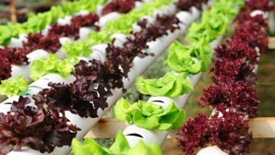
Question 3

A new urban farmer set up pipes to grow lettuce plants hydroponically. He ran water without fertilizer through the pipes.

What do you think his lettuce plants looked like?

Type your answer here.

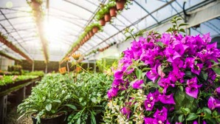
Question 4

How do greenhouses produce an environment that helps plant growth?

Type your answer here.

Question 5

Why do humans use technology when they grow crops?

Type your answer here.

Congratulations! You have completed this self-check quiz.

Now it's time to carefully compare your answers to the suggested answers in the online course. When comparing, you should feel free to make changes to your answers or make extra notes.

Don't forget to save the quiz whenever you make changes.

Keep this quiz for study purposes. If you want more feedback, share it with your teacher.

