Science 7
Unit B
Lesson 13
Self-Check Quiz

Answer all 5 questions in the spaces provided. Think carefully before typing your answers. If you need help, return to the lesson in the online course. Save your quiz when you are done.

Leave your answers in blue; it will be easier for you and your teacher to see them later.

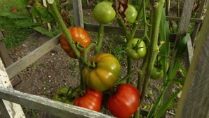
Question 1

A woman bought a tomato plant. It had a strong stem and produced lots of fruit quickly. She saved some seeds from one of the tomatoes. The next spring, the woman planted the saved seeds. Ten new tomato plants grew, but they all looked different from last summer’s plant. Some tomato plants had weak stems. Some plants produced fruit quickly, and some produced fruit slowly.
Explain why the new seeds produced plants different from the parent plant.

Type your answer here.

Question 2

What is one example of a vegetable or fruit that has been selectively bred? Explain the characteristic that has been selectively bred.

Type your answer here.

Question 3

What are genes, and why are they important for the function and appearance of plants?

Type your answer here.

Question 4

What are two advantages to using GMO crops?

Type your answer here.

Question 5

What are two concerns about using GMO crops?

Type your answer here.

Congratulations! You have completed this self-check quiz.

Now it's time to carefully compare your answers to the suggested answers in the online course. When comparing, you should feel free to make changes to your answers or make extra notes.

Don't forget to save the quiz whenever you make changes.

Keep this quiz for study purposes. If you want more feedback, share it with your teacher.

