Science 7
Unit B
Lesson 14
Self-Check Quiz

Answer all 5 questions in the spaces provided. Think carefully before typing your answers. If you need help, return to the lesson in the online course. Save your quiz when you are done.

Leave your answers in blue; it will be easier for you and your teacher to see them later.


Question 1

Kudzu plants were introduced to the United States from Japan in the 1800s. Kudzu vines grow quickly over existing plants and trees.

Why is kudzu a problem in the United States?

Type your answer here.

Question 2

What is one advantage of using pesticides?

Type your answer here.

Question 3

What is one disadvantage of using pesticides?

Type your answer here.

Question 4

Why is protecting biodiversity important?

Type your answer here.

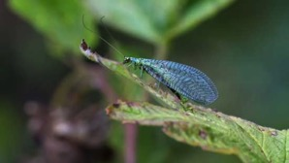
Question 5

A boy noticed that the plants in his garden had fewer tiny aphids than they had previous years. He also noticed some large insects called green lacewings.

What is the best explanation for why fewer aphids are in the garden?

Type your answer here.

Congratulations! You have completed this self-check quiz.

Now it's time to carefully compare your answers to the suggested answers in the online course. When comparing, you should feel free to make changes to your answers or make extra notes.

Don't forget to save the quiz whenever you make changes.

Keep this quiz for study purposes. If you want more feedback, share it with your teacher.

