Science 7
Unit B
Section 4
Self-Check Quiz

Answer all 5 questions in the spaces provided. Think carefully before typing your answers. If you need help, return to the lesson in the online course. Save your quiz when you are done.

Leave your answers in blue; it will be easier for you and your teacher to see them later.

Question 1

Imagine that you are having a discussion with a friend about GMO crops. Your friend says, “GMO crops are bad because they harm people. They should be banned.” What different perspective on GMO crops could you share with your friend?

Type your answer here.

Question 2

Imagine that you are having a discussion with a friend about pesticides. Your friend says, “We should not stop farmers from using pesticides. Without pesticides, we couldn’t grow food.” What different perspective on pesticides could you share with your friend?

Type your answer here.

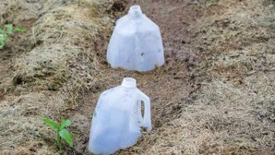
Question 3

In the early spring, a woman cuts the bottoms from empty milk jugs and places the jugs over the seedlings in her garden. Why?

Type your answer here.

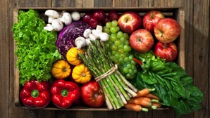
Question 4

Community supported agriculture (CSA) farms are becoming popular across Canada and the USA. People buy a summer subscription to a CSA farm to get a big box of various kinds of fresh vegetables every week. CSA farms usually are small and operated by families. How do CSA farms help increase biodiversity?

Type your answer here.

Question 5

How do organic farmers produce healthy crops without the use of human-made chemicals?

Type your answer here.

Congratulations! You have completed this self-check quiz.

Now it's time to carefully compare your answers to the suggested answers in the online course. When comparing, you should feel free to make changes to your answers or make extra notes.

Don't forget to save the quiz whenever you make changes.

Keep this quiz for study purposes. If you want more feedback, share it with your teacher.

