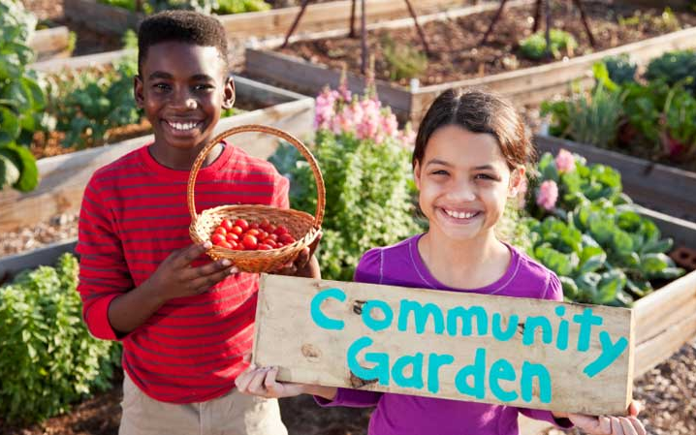
Science 7
Unit B
Project
Community Garden Design

You are required to submit this project to your teacher for marks. Very carefully, read the project task and how to do it. Be sure to read the rubric, which explains the expectations for this project.

Situation

Your town or neighbourhood in Alberta wants to build a community garden. The garden will be used to grow fruits and vegetables for the local Food Bank as well as being a community space that people can enjoy.

The adults in charge of this project want input from young people such as you about how to develop a beautiful and useful garden.

Project Task

Plan and design a community garden for your town or neighbourhood. The garden design should show imagination and creativity. The garden must grow healthy fruits and vegetables every year. The plants in the garden should be suitable for the climate of your community.

Before you begin your community garden design, ask yourself these questions:

- What types of plants and vegetables will grow well in the climate where I live? If I don’t know, how will I find out?
- How will I plan to make the garden produce healthy fruits and vegetables year after year?
- What design features will I include so that people want to spend time in the community garden?

Method

Choose the way you would like to communicate your community garden design. Here are some ideas from which you can choose. You might choose to use several together!

- Build a model. Photograph or video your model to share with your teacher.
- Draw a diagram or map with pencil and paper, or use a computer drawing program such as Adobe Photoshop or Gimp.
- Write a detailed description about your design.
- Record a podcast explaining your design.
- Use other creative ideas, but check with your teacher first!

Requirements

In addition to developing your design, you must answer specific questions in some way:

- You can provide written answers to these questions.
- You can include the answers as labels if you decide to do a drawing of your design.
- You can address these questions by recording yourself (and your model and/or drawings) on video.
- You can make an audio recording in which you explain your design very clearly.

You must communicate clearly your responses to the following questions about your community garden design.

- What types of plants will you include in the garden? (You should include at least 10 types of plants.) What adaptations do these plants have for growing in the Alberta climate where you live?

- What types of plants are included to provide food for the local Food Bank? How will you maximize crop yields?

- How does each plant in your garden reproduce? Will you need to encourage or discourage reproduction of each type of plant to maintain your garden design year after year?

- What types of nutrients do the plants need to produce their own food and to grow larger? How will you provide these nutrients to the plants?

- What kind or kinds of soil do you need in your garden? How will you keep the soil healthy in the garden? Why did you choose these methods?

- How will you stop pests or weeds from destroying plants in the garden? Why did you choose these methods?

- How will you ensure that other nearby ecosystems are not negatively affected by the community garden?

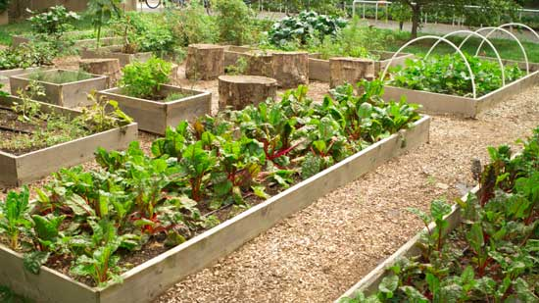
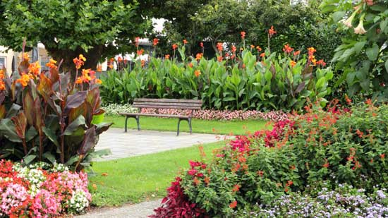

Rubric
A rubric explains how your work will be assessed. It explains clearly all the aspects you must include in your assessment. Read it very carefully before you start your work.

Design a Community Garden
36 marks
CRITERIA | PERFORMANCE
CRITERIA |  | NOT OK | OK | GOOD | EXCELLENT
CRITERIA | Not Submitted  0 marks | Does not meet criteria  1 mark | Minimally meets criteria  2 marks | Fully meets criteria  3 marks | Exceeds criteria  4 marks
Plants listed and connected to adaptations | Not  Submitted | No plants are listed or connected to adaptations; details are lacking. | Some (less than 10) plants are listed or connected to adaptations, but they are confusing. | Ten plants are listed and connected to adaptations; some supporting details are provided. | More than 10 plants are listed and connected to adaptations; several supporting details are provided.
Edible plants listed and connected to crop yields | Not  Submitted | No edible plants are listed or connected to crop yields; details are lacking. | Some edible plants are listed or connected to crop yields, but they are confusing and/or details are lacking. | Edible plants are listed and connected to crop yields; some supporting details are provided. | Edible plants are listed and connected to crop yields; several supporting details are provided.
Reproduction of plants connected to garden design | Not  Submitted | No plant reproduction is mentioned or connected to design; details are lacking. | Plant reproduction is mentioned but not connected to design; details are lacking. | Plant reproduction is mentioned and connected to design; some supporting details are provided. | Plant reproduction is mentioned and connected to design; several supporting details are provided.
Plant nutrients listed; methods of delivery described | Not  Submitted | No plant nutrients, or methods of delivery are listed or described; details are lacking. | Plant nutrients or methods of delivery are listed but not described; details are lacking. | Plant nutrients, and methods of delivery are listed and described; some supporting details are provided. | Plant nutrients and methods of delivery are listed and described; several supporting details are provided.
Soil type and soil health method listed, described, and justified | Not  Submitted | No soil type or soil health method is listed, described, or justified; details are lacking. | Soil type or soil health method is listed but not described or justified; details are lacking. | Soil type and soil health methods are listed, described, and justified; some supporting details are provided | Soil type and soil health methods are listed, described, and justified; several supporting details are provided.
Pest and weed control methods mentioned, described and justified | Not  Submitted | No pest or weed control method is mentioned, described, or justified; details are lacking. | Pest or weed control methods are mentioned but not described or justified; details are lacking. | Pest and weed methods are mentioned, described, and justified; some supporting details are provided. | Pest and weed methods are mentioned, described, and justified; several supporting details are provided.
Ecosystem impact prevention plan described | Not  Submitted | No ecosystem impact prevention plan is mentioned; details are lacking. | Ecosystem impact prevention plan is mentioned; details are lacking. | Ecosystem impact prevention plan is mentioned; some supporting details are provided. | Ecosystem impact prevention plan is mentioned; several supporting details are provided.
Creativity | Not  Submitted | Design is very simple and lacks imagination. | Design is very simple but shows some imagination. | Design has a few features and shows some imagination. | Design has several features and shows much imagination.
Communication | Not  Submitted | Design is not communicated clearly; details are lacking. | Design is communicated partially; some details are confusing or lacking. | Design is communicated partially; many details are included. | Design is communicated clearly with several details.

Submitting Your Work

If you do this project as pencil drawing(s) on another piece of paper, you will have to scan your work to submit it.

If you have prepared any other electronic images or documents for this project, you will need to submit them. The same goes for any Internet location where your work is located, you will need to submit the URL so your teacher can view your work.

When you are ready to submit your completed project, return to the Unit B project page in your course and click the “Add submission” button at the bottom of the page and follow the directions.

Note that when you submit anything to your teacher, PLEASE INCLUDE YOUR NAME IN THE DOCUMENT TITLE. For example, you might title it something like this:

UnitB_project_Jenny_Smith.doc

