Science 7
Unit C
Lesson 2
Self-Check Quiz

Answer all 5 questions in the spaces provided. Think carefully before typing your answers. If you need help, return to the lesson in the online course. Save your quiz when you are done.

Leave your answers in blue; it will be easier for you and your teacher to see them later.

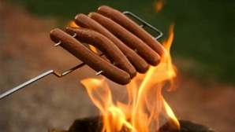
Question 1

Hot dogs contain lots of water. Why do hot dogs sometimes split when they are cooked on a campfire?

Type your answer here.

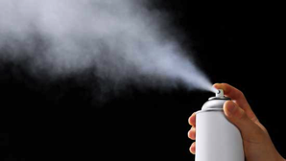
Question 2

Aerosol cans contain liquid particles packed into a metal container. Why is exposing an aerosol can to high heat very dangerous?

Type your answer here.


Question 3

Why does a soccer ball deflate if it is left outside during winter?

Type your answer here.

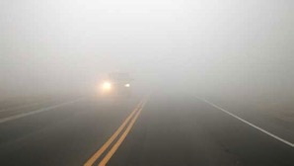
Question 4

Fog forms often when moist warm air cools suddenly. Why does fog look like a white cloud?

Type your answer here.


Question 5

On winter mornings below 0°C, you might have to scrape frost from the windows of your car to ensure good visibility. Why does frost form on cars?

Type your answer here.

Congratulations! You have completed this self-check quiz.

Now it's time to carefully compare your answers to the suggested answers in the online course. When comparing, you should feel free to make changes to your answers or make extra notes.

Don't forget to save the quiz whenever you make changes.

Keep this quiz for study purposes. If you want more feedback, share it with your teacher.

