Science 7
Unit C
Lesson 3
Self-Check Quiz

Answer all 5 questions in the spaces provided. Think carefully before typing your answers. If you need help, return to the lesson in the online course. Save your quiz when you are done.

Leave your answers in blue; it will be easier for you and your teacher to see them later.

Question 1

If a scientist measured the average kinetic energy of all the particles in a substance, what would she be measuring?

Type your answer here.

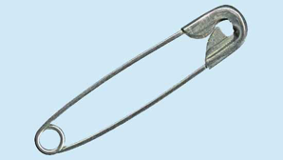
Question 2

A cold metal cooking pot has a temperature of 0°C. A safety pin has a temperature of 10 °C. However, the metal pot has more thermal energy than the safety pin has. How can the metal pot have more energy than the safety pin when its temperature is lower?

Type your answer here.

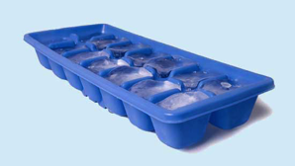
Question 3

Fill an ice cube tray with warm water and put it into the freezer. Explain how the water freezes into ice, using the terms “kinetic energy” and “heat”.

Type your answer here.

Question 4

Why are cryogenic liquids dangerous if humans do not handle them carefully?

Type your answer here.

Question 5

Why are 0 °C, 32 °F, and 273.15 K the same temperature, and what is important about this temperature?

Type your answer here.

Congratulations! You have completed this self-check quiz.

Now it's time to carefully compare your answers to the suggested answers in the online course. When comparing, you should feel free to make changes to your answers or make extra notes.

Don't forget to save the quiz whenever you make changes.

Keep this quiz for study purposes. If you want more feedback, share it with your teacher.

