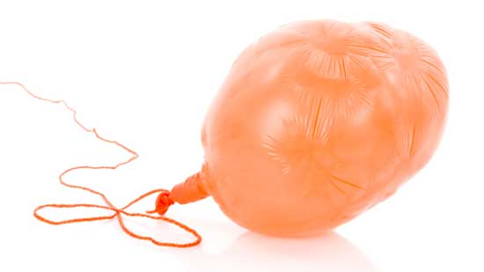
Science 7
Unit C, Lesson B4
Try It!
Expanding and Contracting Balloons

Try this simple experiment to see how a gas thermally expands and contracts inside a balloon.

Materials:

- balloon
- tape measure or ruler
- string
- access to freezer
- hair dryer

Instructions:

Record your results in the following chart:

Temperature | Balloon Circumference
Room Temperature
Hot Temperature
Freezing Temperature

- Inflate the balloon and tie it shut.
- Use the string to measure the distance around the balloon, which is the circumference. Start measuring by wrapping the string from the knot where the balloon is tied shut, placing the string around the balloon and back to the knot. Mark your place on the string, remove it, and place it straight on the table. Use a tape measure or ruler to measure the length of the string. Record this circumference on the room temperature row of your chart.
- Hold a hair dryer about 1 metre from the balloon. Turn on the hair dryer at low heat and blow warm air from the hair dryer onto the balloon for 5 minutes.
- Measure the circumference of the balloon as in step 2. Record this circumference on the hot temperature row of your chart.
- Put the balloon into the freezer for 30 minutes.
- Measure the circumference of the balloon as in step 2. Record this circumference on the freezing temperature row of your chart.

Questions:

Think about the following questions very carefully. Then, type answers in the space provided. When you have your answers, click the questions in the online course for feedback.

- In which situation did the balloon expand? Why?

- In which situation did the balloon contract? Why?

