Science 7
Unit C
Section 1
Self-Check Quiz

Answer all 5 questions in the spaces provided. Think carefully before typing your answers. If you need help, return to the lesson in the online course. Save your quiz when you are done.

Leave your answers in blue; it will be easier for you and your teacher to see them later.

Question 1

What are two reasons heat is important to humans?

Type your answer here.


Question 2

The first step in making gold jewellery is to melt solid gold and pour the liquid gold into a mould. What happens to the particles in liquid gold as it solidifies in the mould?

Type your answer here.

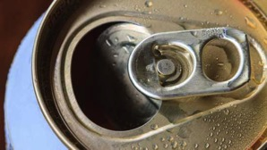
Question 3

If you take a cold pop can from the fridge on a very hot day, little drops of water form on the outside of the pop can. Why does this happen?

Type your answer here.

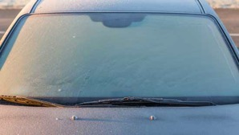
Question 4

When it is extremely cold outside, people warm their cars before starting to drive. If a person starts to drive before the car is warm inside, frost can form on the inside of the windows of the car. Why can frost form on the inside of the car in this situation?

Type your answer here.


Question 5

Why you should not over-inflate your bicycle tires in the summer?

Type your answer here.

Congratulations! You have completed this self-check quiz.

Now it's time to carefully compare your answers to the suggested answers in the online course. When comparing, you should feel free to make changes to your answers or make extra notes.

Don't forget to save the quiz whenever you make changes.

Keep this quiz for study purposes. If you want more feedback, share it with your teacher.

