Science 7
Unit C
Lesson 5
Self-Check Quiz

Answer all 5 questions in the spaces provided. Think carefully before typing your answers. If you need help, return to the lesson in the online course. Save your quiz when you are done.

Leave your answers in blue; it will be easier for you and your teacher to see them later.

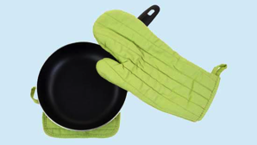
Question 1

A cast iron frying pan is placed on a hot stove burner. After a few minutes, why do you need to wear a glove to lift the frying pan safely?

Type your answer here.

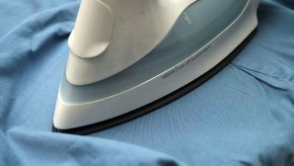
Question 2

Why should a hot clothes iron never be left face-down on an ironing board?

Type your answer here.

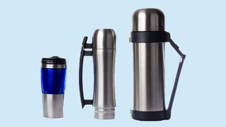
Question 3

A Thermos bottle is has an outer metal layer and an inner metal layer (or sometimes plastic and glass). The two layers are separated by a vacuum, which is empty space containing very few air particles. How does the design of a Thermos bottle keep liquids their original temperature for hours?

Type your answer here.

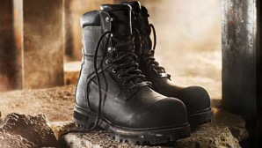
Question 4

Construction workers are required to wear protective boots for safety. The toe areas of such boots are surrounded by steel or a strong composite material. Steel-toed boots protect toes, but they can result in cold feet during winter. Why do steel-toed boots cause cold feet more than other types of boots do?

Type your answer here.

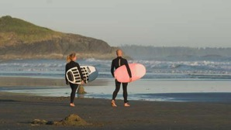
Question 5

Explain why surfers on the west coast of British Columbia usually wear wetsuits when surfing at any time of the year.

Type your answer here.

Congratulations! You have completed this self-check quiz.

Now it's time to carefully compare your answers to the suggested answers in the online course. When comparing, you should feel free to make changes to your answers or make extra notes.

Don't forget to save the quiz whenever you make changes.

Keep this quiz for study purposes. If you want more feedback, share it with your teacher.

