Science 7
Unit C
Lesson 6
Self-Check Quiz

Answer all 5 questions in the spaces provided. Think carefully before typing your answers. If you need help, return to the lesson in the online course. Save your quiz when you are done.

Leave your answers in blue; it will be easier for you and your teacher to see them later.

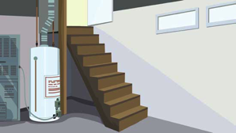
Question 1

In the summer, why is the basement of a house cooler than the top floor is?

Type your answer here.

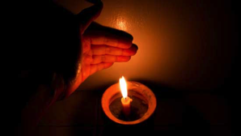
Question 2

When you put your hand near a candle, you feel heat directly over the flame but cool on the sides of the flame. Why does this difference occur?

Type your answer here.

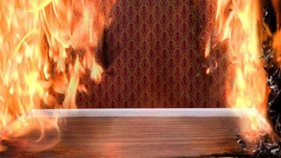
Question 3

Explain why firefighters tell people to stay low to the ground while escaping a house fire.

Type your answer here.


Question 4

A room with a high ceiling always feels cold in the winter, even when the fireplace is lit. What is the best explanation for this observation?

Type your answer here.


Question 5

Turbulence can cause airplane rides to feel bumpy. Explain why airplanes approaching the ground on a hot day often experience turbulence.

Type your answer here.

Congratulations! You have completed this self-check quiz.

Now it's time to carefully compare your answers to the suggested answers in the online course. When comparing, you should feel free to make changes to your answers or make extra notes.

Don't forget to save the quiz whenever you make changes.

Keep this quiz for study purposes. If you want more feedback, share it with your teacher.

