Science 7
Unit C
Lesson 7
Self-Check Quiz

Answer all 5 questions in the spaces provided. Think carefully before typing your answers. If you need help, return to the lesson in the online course. Save your quiz when you are done.

Leave your answers in blue; it will be easier for you and your teacher to see them later.

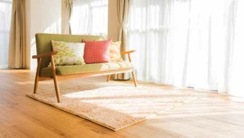
Question 1

To spend less money on heating fuel, a family designs a house to have lots of windows on the south side of the house. Explain why windows on the south side of a house can help reduce home heating costs.

Type your answer here.

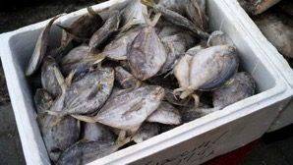
Question 2

Explain why coolers for transporting frozen fish or meat often are white-coloured.

Type your answer here.


Question 3

Cities with lots of concrete have hotter temperatures during the summer than nearby rural areas have. What is the best explanation for this observation?

Type your answer here.

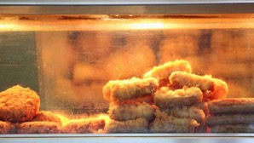
Question 4

In restaurants, chefs place food under lamps while waiting for servers to carry it to the tables. Explain why food is put under lamps.

Type your answer here.

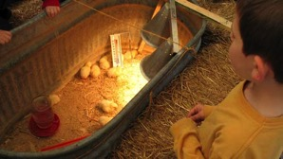
Question 5

Pens of baby chicks often contain lamps. Explain why lamps are used in chick pens.

Type your answer here.

Congratulations! You have completed this self-check quiz.

Now it's time to carefully compare your answers to the suggested answers in the online course. When comparing, you should feel free to make changes to your answers or make extra notes.

Don't forget to save the quiz whenever you make changes.

Keep this quiz for study purposes. If you want more feedback, share it with your teacher.

