Science 7
Unit C
Section 2
Self-Check Quiz

Answer all 5 questions in the spaces provided. Think carefully before typing your answers. If you need help, return to the lesson in the online course. Save your quiz when you are done.

Leave your answers in blue; it will be easier for you and your teacher to see them later.

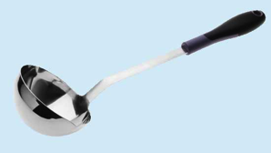
Question 1

Why do metal soup ladles often have wooden or plastic handles?

Type your answer here.


Question 2

Emergency blankets often are included in First Aid kits. They are used to keep people warm outdoors in emergency situations. Explain why emergency blankets are made of reflective silver materials.

Type your answer here.

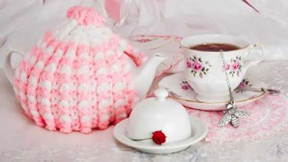
Question 3

Explain why people sometimes put a little knitted coat called a tea cozy around a pot of hot tea.

Type your answer here.

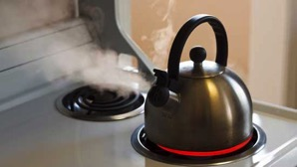
Question 4

Only the bottom of a tea kettle touches the heating element on a stove. How does heat transfer quickly to all the water inside the kettle?

Type your answer here.


Question 5

Why does your body feel cooler if you sit in the shade on a hot sunny day?

Type your answer here.

Congratulations! You have completed this self-check quiz.

Now it's time to carefully compare your answers to the suggested answers in the online course. When comparing, you should feel free to make changes to your answers or make extra notes.

Don't forget to save the quiz whenever you make changes.

Keep this quiz for study purposes. If you want more feedback, share it with your teacher.

