Science 7
Unit C, Section 2
Project
Ultimate Camping Cooler
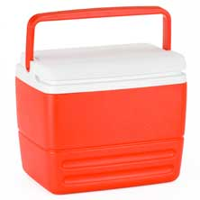
You are required to submit this project to your teacher for marks. Very carefully, read the project task and how to do it. Be sure to read the rubric, which explains the expectations for this project.

Situation

You are leaving this afternoon for an overnight summer camping trip without any electricity. You want to pack some ice cream to eat tomorrow afternoon. How will you keep the ice cream frozen for 24 hours without electricity? Ice often melts after 12 hours in a regular camping cooler.

To solve your problem, you need to develop the ultimate camping cooler.

Proejct Task

Design a camping cooler that keeps food completely frozen for 24 hours.

Before you begin your design, ask yourself these questions:

"What do I know about preventing heat transfer?"
"What materials help prevent heat transfer?"

Method

Choose the way you would like to communicate your design. You can choose from the following ideas.

- Build and test a real camping cooler. Then, photograph or video various aspects of your camping cooler to share with your teacher.
- Draw several pictures to show clearly the interior and exterior features of your camping cooler design. Use pencil and paper, or use a computer drawing program such as Adobe Photoshop or Gimp.
- Write a detailed description or story about your camping cooler design.
- Use any other creative ideas you have, but check with your teacher first!

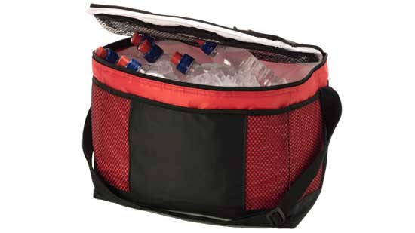

Requirements

Below you see 3 questions. It is very important that when you answer the questions, you keep in mind that you need to explain your cooler design very clearly. How you answer the questions is up to you. Here are some options:

- You can provide written answers to these questions.
- You can include the answers as labels if you produce a drawing of your design.
- Another option is to address these questions by recording yourself (and your model or drawings) on video or make an audio recording.

Questions

- How does your camping cooler design prevent heat transfer by conduction? What materials did you choose to help with this?
- How does your camping cooler design prevent heat transfer by convection? What materials did you choose to help with this?
- How does your camping cooler design prevent heat transfer by radiation? What materials did you choose to help with this?

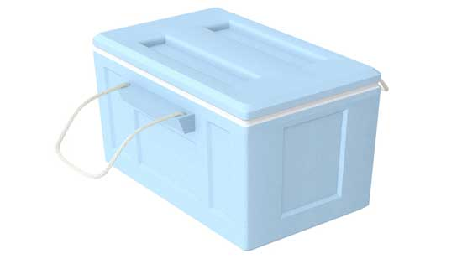

Rubric

This rubric explains how your project will be marked. It explains everything you must include in your project. Read it very carefully before you start your project.

Ultimate Camping Cooler
20 marks

CRITERIA | PERFORMANCE
CRITERIA |  | NOT OK | OK | GOOD | EXCELLENT
CRITERIA | Not Submitted  0 marks | Does not meet criteria  1 mark | Meets criteria minimally  2 marks | Meets criteria fully  3 marks | Exceeds  criteria  4 marks
Conduction connected to design | Not  Submitted | Conduction is not mentioned or connected to design; details are lacking. | Conduction is mentioned but not connected to design; details are lacking. | Conduction is mentioned and connected to design; some supporting details are given. | Conduction is mentioned and connected to design; many supporting details are given.
Convection connected to design | Not  Submitted | Convection is not mentioned or connected to design; details are lacking. | Convection is mentioned but not connected to design; details are lacking. | Convection is mentioned and connected to design; some supporting details are given | Convection mentioned and connected to design; many supporting details
Radiation connected to design | Not  Submitted | Radiation is not mentioned or connected to design; details are lacking. | Radiation is mentioned but not connected to design; details are lacking. | Radiation is mentioned and connected to design; some supporting details are given. | Radiation mentioned and connected to design; many supporting details
Creativity | Not  Submitted | Design is very simple and lacks imagination. | Design is very simple but shows some imagination. | Design has some creative features and shows some imagination. | Design has creative features and shows great imagination.
Communication | Not  Submitted | Design is not clearly communicated; details are lacking. | Design is partly communicated; some details are lacking or confusing. | Design is communicated partly; many details are included. | Design is communicated clearly with much detail.

Submitting Your Work

If you do this project as pencil drawing(s) on another piece of paper, you will have to scan your work to submit it.

If you have prepared any other electronic images or documents for this project, you will need to submit them. The same goes for any Internet location where your work is located, you will need to submit the URL so your teacher can view your work.

When you are ready to submit your completed project, return to the project page in your online course and click the “Add submission” button at the bottom of the page and follow the directions.

Note that when you submit anything to your teacher, PLEASE INCLUDE YOUR NAME IN THE DOCUMENT TITLE. For example, you might title it something like this:

UnitC_section2project_Jenny_Smith.doc

