Science 7
Unit C
Lesson 8
Self-Check Quiz

Answer all 5 questions in the spaces provided. Think carefully before typing your answers. If you need help, return to the lesson in the online course. Save your quiz when you are done.

Leave your answers in blue; it will be easier for you and your teacher to see them later.


Question 1

A man places a glass jar over a burning candle.

Why does the candle go out after a few minutes?

Type your answer here.


Question 2

People burn fuels such as wood and natural gas to heat their homes.

What is the natural source of energy in fuels?

Type your answer here.


Question 3

When a piece of wood is cut with a saw, both the wood and the saw feel warm.

What is the natural source of energy heating the wood?

Type your answer here.

Question 4

Explain how warm-blooded animals maintain constant body temperatures.

Type your answer here.

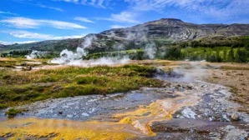
Question 5

Why do some countries such as Iceland use a lot of geothermal energy to meet their heating needs while other countries do not use much geothermal energy?

Type your answer here.

Congratulations! You have completed this self-check quiz.

Now it's time to carefully compare your answers to the suggested answers in the online course. When comparing, you should feel free to make changes to your answers or make extra notes.

Don't forget to save the quiz whenever you make changes.

Keep this quiz for study purposes. If you want more feedback, share it with your teacher.

