Science 7
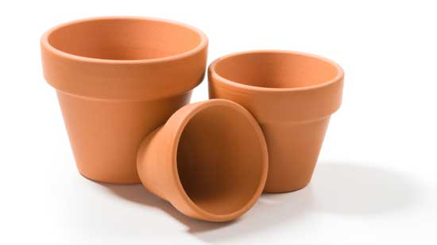
Unit C, Lesson C10
Try It!
Make a Clay Pot Cooler

Try making your own clay pot cooler, and test how effective it is at keeping food cold.

Materials:

- 1 large terracotta clay pot
- 1 small terracotta clay pot that fits into the first pot
- sand
- water
- modelling clay
- piece of cloth to cover the top of the small pot
- thermometer
- timer

Instructions:

- If there are holes at the bottom of the clay pots, plug the holes with modelling clay.

- Put sand in the bottom of the large pot. When you put the smaller pot on top of the sand, the tops of both pots should be at the same level.

- Put the smaller pot inside the larger pot.

- Fill the space between the two pots with sand.

- Pour water slowly on the sand. The sand should feel wet. (Don’t drown it!)

- Make the cloth wet. Put the wet cloth over the smaller pot.

- Put the thermometer inside the small clay pot.

- Measure the temperature inside the clay pot. Record this temperature.

- Leave the thermometer inside the clay pot. Measure and record the temperature of the clay pot every 20 minutes for 3 hours. Record the temperatures in a chart such as the following:

Time | Temperature
Initial
20 minutes
40 minutes
1 hour
1 hour 20 minutes
1 hour 40 minutes
2 hours
2 hours 20 minutes
2 hours 40 minutes
3 hours

Questions:

Think about the following questions very carefully. Then, type answers in the space provided. When you have your answers, click the questions in the online course for feedback.

- What causes the clay pot cooler to become cold?

- Why does the clay pot cooler have a wet cloth on top?

