Science 7
Unit C
Lesson 10
Self-Check Quiz

Answer all 5 questions in the spaces provided. Think carefully before typing your answers. If you need help, return to the lesson in the online course. Save your quiz when you are done.

Leave your answers in blue; it will be easier for you and your teacher to see them later.

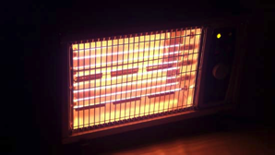
Question 1

Some climates stay above zero degrees Celsius in the winter. Homes in these climates usually do not have central heating systems such as boilers and furnaces. Instead, people might use portable space heaters to warm the room they are using. Explain why people in non-freezing climates use space heaters instead of furnaces or boilers.

Type your answer here.

Question 2

Explain why most people do not use wood fires to heat their homes anymore.

Type your answer here.

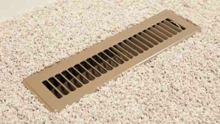
Question 3

Why are hot air heat registers usually located on the floor rather than the ceiling?

Type your answer here.

Question 4

Explain why some space should be left between the back of a fridge and a wall.

Type your answer here.

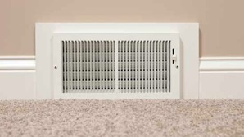
Question 5

Explain why furnace-heated homes have cool air return registers at the bottom of walls.

Type your answer here.

Congratulations! You have completed this self-check quiz.

Now it's time to carefully compare your answers to the suggested answers in the online course. When comparing, you should feel free to make changes to your answers or make extra notes.

Don't forget to save the quiz whenever you make changes.

Keep this quiz for study purposes. If you want more feedback, share it with your teacher.

