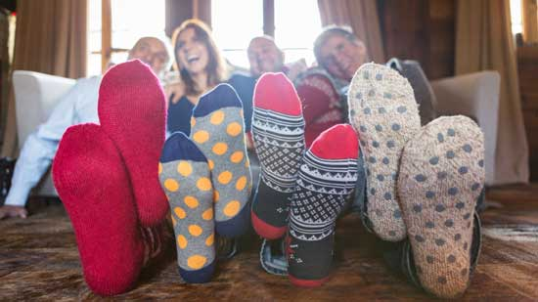
Science 7
Unit C, Lesson C11
Lesson Activity
Testing Insulators

Which materials are best at preventing heat loss? Try this experiment to test various insulators that people wear on their feet.

Materials:

- thermometer
- 6 small jars with lids (such as baby food jars or small canning jars)
- cookie sheet
- hot tap water
- 2 cotton socks
- 4 wool socks
- aluminum foil
- fridge
- timer

Instructions:

- Clear a space in the refrigerator large enough to fit the cookie sheet loaded with jars.
- Place the jars on a cookie sheet.
- Place the thermometer under running hot tap water to measure the temperature of the water. Record this temperature on the Observations Chart as “Initial Temperature” for every jar..
- Fill all the jars with hot tap water and close their lids quickly.
- Place each of the six jars quickly into one of the following insulators:
  - 1 cotton sock
  - 1 cotton sock wrapped in aluminum foil
  - 1 wool sock
  - 2 wool socks
  - 1 wool sock wrapped in aluminum foil
  - Leave one jar with no insulation.

- Put the cookie sheet with the jars into the fridge for 15 minutes.
- After 15 minutes, remove the cookie sheet from the fridge.
- Remove one jar from an insulator and open the jar’s lid. With the thermometer, measure the temperature of the water in the jar. Record the temperature for the correct insulator on the Observations Chart under “Final Temperature”.
- Repeat Step 8 for the remaining five jars.
- The change in temperature equals the initial temperature minus the final temperature. Calculate and record the change in temperature for all the insulators.

Observations:

Record your observations in this chart:

Jar | Insulator | Initial Temperature (ºC) | Final Temperature (ºC) | Change in Temperature (ºC)
1 | 1 cotton sock
2 | 1 cotton sock wrapped in aluminum foil
3 | 1 wool sock
4 | 2 wool socks
5 | 1 wool sock wrapped in aluminum foil
6 | No insulation

Questions:

Think about the following questions very carefully. Then, type answers in the space provided. When you have your answers, click the questions in the online course for feedback.

- Which jar of water experienced the greatest change in temperature? What does this tell you about the insulating ability of the material?

- Which jar of water experienced the least change in temperature? What does this tell you about the insulating ability of the material?

- Why did the socks wrapped in aluminum foil stay warmer than the socks without aluminum foil?

Questions Continued:

- Why is shiny foil sometimes used to cover the insoles of winter boots?

- How might this experiment affect your personal choice of winter footwear?

