Science 7
Unit C
Lesson 11
Self-Check Quiz

Answer all 5 questions in the spaces provided. Think carefully before typing your answers. If you need help, return to the lesson in the online course. Save your quiz when you are done.

Leave your answers in blue; it will be easier for you and your teacher to see them later.


Question 1

Houses in hot climates have window shutters. People close window shutters during hot summer days. How do window shutters affect heat transfer in a house?

Type your answer here.


Question 2

Why would a person want to obtain a thermogram of his or her home?

Type your answer here.

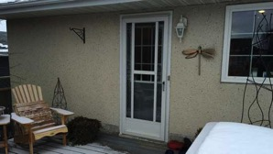
Question 3

Houses in cold climates sometimes have a glass storm door outside of the main door. How do storm doors help insulate houses?

Type your answer here.

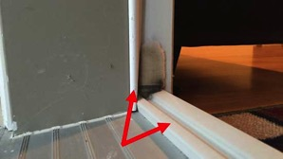
Question 4

Usually, weatherstripping is a thin strip of plastic between doors and door frames. Explain why weatherstripping is important for homes in cold climates.

Type your answer here.


Question 5

Why does wearing layers of clothing in cold weather keep your body warm?

Type your answer here.

Congratulations! You have completed this self-check quiz.

Now it's time to carefully compare your answers to the suggested answers in the online course. When comparing, you should feel free to make changes to your answers or make extra notes.

Don't forget to save the quiz whenever you make changes.

Keep this quiz for study purposes. If you want more feedback, share it with your teacher.

