Science 7
Unit C
Section 3
Self-Check Quiz

Answer all 5 questions in the spaces provided. Think carefully before typing your answers. If you need help, return to the lesson in the online course. Save your quiz when you are done.

Leave your answers in blue; it will be easier for you and your teacher to see them later.

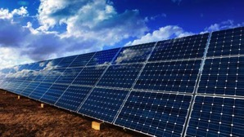
Question 1

Why is active solar power not a main source of our electricity?

Type your answer here.


Question 2

How would you design a house to be heated by means of passive solar energy?

Type your answer here.

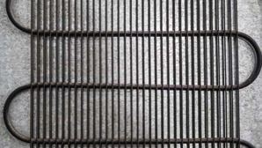
Question 3

The coolant coil in a refrigerator has a leak. Explain how the coolant leak affects the fridge.

Type your answer here.

Question 4

Explain any two methods that humans use to heat their homes. (This is not necessarily two kinds of furnaces! Think of the ways that heat transfers.)

Type your answer here.

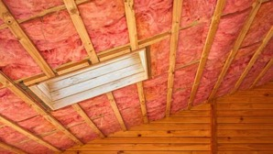
Question 5

Why is home insulation important in both hot and cold weather?

Type your answer here.

Congratulations! You have completed this self-check quiz.

Now it's time to carefully compare your answers to the suggested answers in the online course. When comparing, you should feel free to make changes to your answers or make extra notes.

Don't forget to save the quiz whenever you make changes.

Keep this quiz for study purposes. If you want more feedback, share it with your teacher.

