Science 7
Unit C
Lesson 13
Self-Check Quiz

Answer all 5 questions in the spaces provided. Think carefully before typing your answers. If you need help, return to the lesson in the online course. Save your quiz when you are done.

Leave your answers in blue; it will be easier for you and your teacher to see them later.


Question 1

What are two ways that you can reduce energy use in your everyday life? Explain carefully.

Type your answer here.

Question 2

Why should people care about energy conservation? Explain carefully.

Type your answer here.

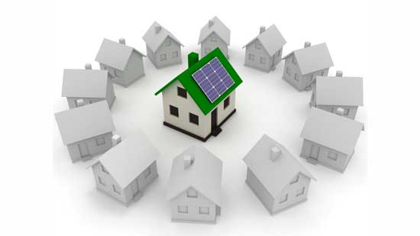
Question 3

Explain one improvement that can be made to a house to conserve energy.

Type your answer here.

Question 4

What are two ways that people can use less energy in transportation?

Type your answer here.

Question 5

What is Energy Star used for?

Type your answer here.

Congratulations! You have completed this self-check quiz.

Now it's time to carefully compare your answers to the suggested answers in the online course. When comparing, you should feel free to make changes to your answers or make extra notes.

Don't forget to save the quiz whenever you make changes.

Keep this quiz for study purposes. If you want more feedback, share it with your teacher.

