Science 7
Unit C
Section 4
Self-Check Quiz

Answer all 5 questions in the spaces provided. Think carefully before typing your answers. If you need help, return to the lesson in the online course. Save your quiz when you are done.

Leave your answers in blue; it will be easier for you and your teacher to see them later.

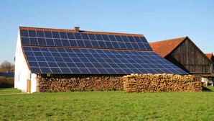
Question 1

A rural family wants to build an off-grid house. What energy sources would you recommend to them and why?

Type your answer here.

Question 2

Your friend tells you that tidal energy is the best source of energy possible. What alternative viewpoint on this issue can you share with your friend?

Type your answer here.

Question 3

Your friend tells you that Canada should use 100% renewable solar energy by next year. Explain to your friend that this is not possible.

Type your answer here.

Question 4

An eco-club at a local junior high school is trying to teach students about conserving energy. The members are making posters to tell students how to save energy at school. What are some ideas the eco-club kids could share on their posters?

Type your answer here.

Question 5

You hear your parents mention that the electricity bill has gone up. What advice could you share with your family to help reduce the cost of electricity?

Type your answer here.

Congratulations! You have completed this self-check quiz.

Now it's time to carefully compare your answers to the suggested answers in the online course. When comparing, you should feel free to make changes to your answers or make extra notes.

Don't forget to save the quiz whenever you make changes.

Keep this quiz for study purposes. If you want more feedback, share it with your teacher.

