Science 7
Unit C Project
Low Energy Community Centre Action Plan

You are required to submit this project to your teacher for marks. Very carefully, read the project task and how to do it. Be sure to read the rubric, which explains the expectations for this project.

Situation

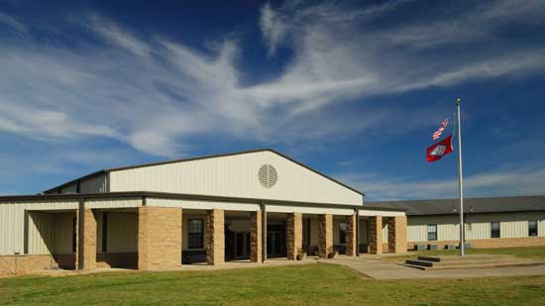
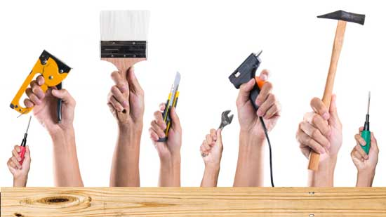

Your local community centre is a great place for people to gather. The community centre offers sports, fitness, and dance classes in the gym. Some people like to exercise early in the morning, so the locker rooms have showers for people to clean up before going to work. One room in the community centre is used as a preschool, and another is used for art classes.

People rent the community centre hall for special events such as parties and weddings. The building has a kitchen where people can prepare food for special events. In addition, the kitchen is used to prepare snacks for the preschool children and to make coffee for a daily seniors’ coffee time.

The community centre was built 50 years ago, and it has received no major renovations since then. Lately, the community centre leaders are aware that the costs of heat and electricity have increased. Long-term, they would like to reduce the community centre’s energy usage. To do this, more heat and electric energy must be conserved in the community centre. That means to use less!

The community centre leaders know that energy conservation requires two main actions. Some renovations must be made to the community centre, and people using the community centre must change some of their habits of energy use.

The community centre leaders want input from young people such as you as they determine what changes to make. They want to make an energy conservation action plan.


Project Task

Develop an action plan to conserve energy in a community centre. The action plan should include recommendations for energy-saving building renovations as well as behaviours that people can change to conserve energy.

Before you begin your plan, ask yourself some questions:

- Where in buildings is energy often wasted?
- What renovations could be made to make buildings more energy efficient?
- What habits could people change to use less energy?

Method

- Research at least five building renovation improvements that could be made to the community centre. Sources of information can include the following:

  - Lesson C10, C11, C12, and C13
  - Reference books
  - News articles in newspapers and magazines or other publications
  - Websites
  - YouTube videos
  - Interviews with adults who work in the building industry

- Think about where energy might be wasted in the community centre. Research at least ten habits that people using the community centre could adopt to save energy. Sources of information can include the following:

  - Lesson C13
  - https://www.energystar.gov/index.cfm?fuseaction=popuptool.atHome
  - Reference books
  - News articles in newspapers and magazines or other publications
  - Websites
  - YouTube videos
  - Interviews with adults who have been active in conservation of energy

- Construct two tables to collect information. One table will summarize five home renovation improvements and the other will summarize ten energy-saving habits.

The table must contain information summarized in your own words. Beside each piece of supporting information, provide the source of the information. For example, insert the URL of any websites, titles and authors of books, names and dates of newspapers, or names of people interviewed as your sources.

You must submit the two tables with your action plan.

 | Information about Renovation Improvements
 | Supporting Information | Supporting Information
1.
2.
3.
4.
5.

 | Information about Energy-Saving Habits
 | Supporting Information | Supporting Information
1.
2.
3.
4.
5.
6.
7.
8.
9.
10.

- Choose a way to communicate your action plan. Here are some ideas from which you may choose:

- Video a presentation.
- Build a model. Photograph or video your model to share with your teacher.
- Draw a poster by hand, or use a computer drawing program.
- Write a detailed report.
- Build a website.
- Use other creative ideas, but check with your teacher first!
Requirements
You must communicate clearly the following information in your action plan:

- Five renovations that the community centre could do to reduce heat transfer in the building
  - Your reasons for recommending each of these renovations
  - Ways the renovations reduce heat transfer by conduction, convection, and radiation
  - Building materials used in the renovations to help reduce heat transfer
  - Consideration of passive and active solar heating in the building renovations

- Ten habits you recommend people adopt to conserve energy
  - Descriptions of each habit
  - Explanation of your reasons for recommending each habit.

Rubric
This rubric explains how your project will be marked. It explains everything you must include in your project. Read it very carefully before you start your project.

Low Energy Home Action Plan
28 marks
CRITERIA | PERFORMANCE
CRITERIA |  | NOT OK | OK | GOOD | EXCELLENT
CRITERIA | Not Submitted  0 marks | Does not meet criteria  1 mark | Meets criteria minimally  2 marks | Meets criteria  fully  3 marks | Exceeds  criteria  4 marks
Research tables completed | Not  Submitted | Research tables are not complete; they lack details and sources of information. | Research tables are somewhat complete; some details and sources of information are confusing or lacking. | Research tables and sources of information are complete; some supporting details and examples are provided. | Research tables and sources of information are complete; several supporting details and examples are provided.
Five building renovations listed and explained | Not  Submitted | No renovations are listed or explained; details are lacking. | Some renovations are listed or explained, but they are confusing. | Renovations are listed and explained; some supporting details are provided. | Renovations are listed and explained; many supporting details are provided.
Conduction, convection, and radiation connected to renovations | Not  Submitted | No methods of heat transfer are mentioned or connected to renovations; details are lacking. | Heat transfer is mentioned but not connected to renovations; details are lacking. | Heat transfer is mentioned and connected to renovations; some supporting details are provided. | Heat transfer is mentioned and connected to renovations; several supporting details are provided.
Building materials reducing heat transfer listed and explained | Not  Submitted | No building materials are listed or explained; details are lacking. | Some building materials are listed or explained, but they are confusing. | Building materials are listed and explained; some supporting details are provided. | Building materials are listed and explained; several supporting details are provided.
Passive and active solar heating mentioned and described | Not  Submitted | No passive and active solar heating are mentioned and described; details are lacking. | Passive and active solar heating are mentioned but not described; details are lacking. | Passive and active solar heating are mentioned and described; some supporting details are provided. | Passive and active solar heating are mentioned and described; several supporting details are provided.
Ten energy conservation habits described | Not  Submitted | No energy conservation habits are mentioned; details are lacking. | Some energy conservation habits mentioned; details are lacking. | Ten energy conservation habits mentioned; some supporting details are provided. | Ten energy conservation habits are mentioned; several supporting details are provided.
Communication | Not  Submitted | Action plan communicates inadequately; details are lacking. | Action plan communicates partially; some details are confusing or lacking. | Action plan communicates somewhat effectively with some details. | Action plan communicates clearly with much detail.

Submitting Your Work

If you do this project as pencil drawing(s) on another piece of paper, you will have to scan your work to submit it.

If you have prepared any other electronic images or documents for this project, you will need to submit them. The same goes for any Internet location where your work is located, you will need to submit the URL so your teacher can view your work.

When you are ready to submit your completed project, return to the project page in your online course and click the “Add submission” button at the bottom of the page and follow the directions.

Note that when you submit anything to your teacher, PLEASE INCLUDE YOUR NAME IN THE DOCUMENT TITLE. For example, you might title it something like this:

UnitC_Project_Jenny_Smith.doc

