Science 7
Unit D
Section 1
Self-Check Quiz

Answer all 5 questions in the spaces provided. Think carefully before typing your answers. If you need help, return to the lesson in the online course. Save your quiz when you are done.

Leave your answers in blue; it will be easier for you and your teacher to see them later.

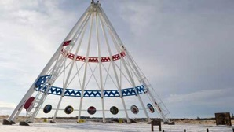
Question 1

Is the Saamis Tipi in Medicine Hat a solid, frame, or shell structure? If you think it is more than one type of structure, be sure to explain your answer.

Type your answer here.

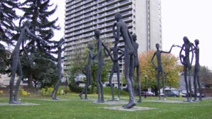
Question 2

Are the Family of Man statues in downtown Calgary a solid, frame, or shell structure? If you think it is more than one type of structure, be sure to explain your answer.

Type your answer here.


Question 3

What is the function of a skateboard?

Type your answer here.

Question 4

A skateboard has interesting design features:

- It has a rough tape on top similar to sandpaper.
- It has smooth, easy-turning wheels.
- The whole skateboard is lightweight.
- Skateboards have two end "lips" that are bent upward.

Explain the function of each of these design features. Why are they included in the skateboard design?

Type your answer here.

Question 5

Why do some structures with the same functions have different designs?

Type your answer here.

Congratulations! You have completed this self-check quiz.

Now it's time to carefully compare your answers to the suggested answers in the online course. When comparing, you should feel free to make changes to your answers or make extra notes.

Don't forget to save the quiz whenever you make changes.

Keep this quiz for study purposes. If you want more feedback, share it with your teacher.

