Science 7
Unit D, Section 1
Project
Design Your Own Clubhouse

You are required to submit this project to your teacher for marks. Very carefully, read the project task and how to do it. Be sure to read the rubric, which explains the expectations for this project.

Project Task

Design a clubhouse or tree house to meet your needs as a Grade 7 student.
Design both the inside (including furniture) and the outside of the clubhouse.
The design of your clubhouse should show imagination and creativity. Design an interesting clubhouse that serves multiple functions, and is also very pleasing to your eye.

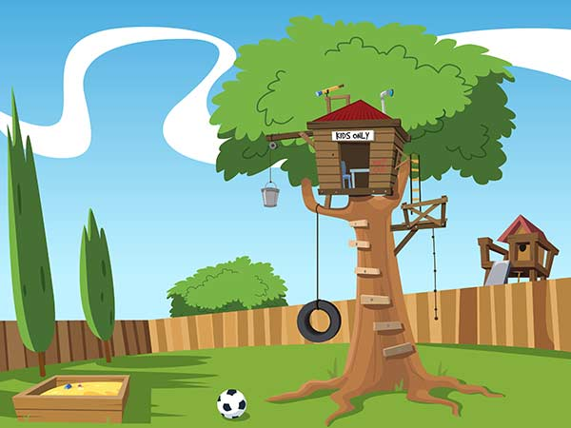

Before starting your design, ask yourself this question:

“What would be the perfect clubhouse or tree house for me, my friends, and the things we like to do?”

Method

You can choose the way that you would like to communicate your design. Here are some ideas that you can pick from:

- Build a model. Photograph or video your model to share with your teacher.
- Draw pictures. You should draw multiple pictures to clearly show the interior and exterior features of your design. Draw your picture with pencil and paper, or use a computer drawing program such as Adobe Photoshop or Gimp.
- Build a structure in Minecraft and take screenshots.
- Write a detailed description or story about your design.
- Any other creative ideas you have, but check with your teacher first!

Requirements

You must clearly communicate the following information about your design. So in addition to creating your design, you must answer the following questions. You can provide written answers to these questions, or you can include the answers as labels if you decide to do a drawing of your design.

Another option is to address these questions by recording yourself (and your model/drawings) on video, or make an audio recording. Just be sure to explain your design very clearly.

- What are the functions of your clubhouse?
- What design features are you including to meet these functions?
- What kind of climate is your clubhouse going to be built in? How does the climate influence the design of your clubhouse?
- Include aesthetics in your clubhouse design. Explain the design features you have added to your design to make it aesthetically pleasing.
- Identify the solid, frame, and shell structures in your clubhouse. Why are each of these types of structures used in your design?

Rubric

This rubric explains how your project will be marked. It explains everything you must include in your project. Read it very carefully before you start your project.

Design Your Own Clubhouse
24 marks

CRITERIA | PERFORMANCE
CRITERIA |  | NOT OK | OK | GOOD | EXCELLENT
CRITERIA | Not Submitted0 marks | Does not meet criteria  1 mark | Minimally meets criteria  2 marks | Fully meets criteria  3 marks | Exceeds criteria  4 marks
Functions listed and connected to design | Not  Submitted | No functions listed or connected to design. Lack of detail. | Some functions listed or connected to design but are confusing. | Functions listed and connected to design. Some supporting details. | Many functions listed and connected to design. Many supporting details.
Climate connected to design | Not  Submitted | No climate mentioned or connected to design. Lack of detail. | Climate mentioned but not connected to design. Lack of detail. | Climate mentioned and connected to design. Some supporting details. | Climate mentioned and connected to design. Many supporting details.
Aesthetics included in design | Not  Submitted | Aesthetics not included in the design. | One or two aesthetic details included in the design. | Some aesthetic details included in the design. | Many interesting aesthetics details included in the design.
Solid, frame, and shell structures identified in design | Not  Submitted | No key structure types identified. | Some key structures identified, but are not connected to purpose. | Key structures identified and connected to purpose. | Key structures identified and connected to purpose and design.
Creativity | Not  Submitted | Design is very simple and lacks imagination. | Design is very simple but shows some imagination. | Design has a few different features and shows some imagination. | Design has many different features and shows a great deal of imagination.
Communication | Not  Submitted | Design is not clearly communicated. | Design is partly communicated, some details lacking or confusing. | Design is partly communicated, many details included. | Design is clearly communicated with much detail.

Submitting Your Work

If you do this project as pencil drawing(s) on another piece of paper, you will have to scan your work to submit it.

If you have prepared any other electronic images or documents for this project, you will need to submit them. The same goes for any Internet location where your work is located, you will need to submit the URL so your teacher can view your work.

When you are ready to submit your completed project, return to the project page in your online course and click the “Add submission” button at the bottom of the page and follow the directions.

Note that when you submit anything to your teacher, PLEASE INCLUDE YOUR NAME IN THE DOCUMENT TITLE. For example, you might title it something like this:

UnitD_Section1Project_Jenny_Smith.doc

