Science 7
Unit D
Lesson 6
Self-Check Quiz

Answer all 5 questions in the spaces provided. Think carefully before typing your answers. If you need help, return to the lesson in the online course. Save your quiz when you are done.

Leave your answers in blue; it will be easier for you and your teacher to see them later.

Question 1

Name two types of external forces on a structure.

Type your answer here.

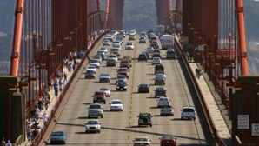
Question 2

Would cars driving across a bridge contribute to the static load or to the dynamic load? Explain your answer.

Type your answer here.

Question 3

Does the bridge deck on a bridge contribute to the static load or to the dynamic load? Explain your answer.

Type your answer here.

Question 4

What is "centre of gravity"?

Type your answer here.

Question 5

Which vehicle is more stable in strong winds: a short, small car or a tall semi-trailer truck? Explain.

Type your answer here.

Congratulations! You have completed this self-check quiz.

Now it's time to carefully compare your answers to the suggested answers in the online course. When comparing, you should feel free to make changes to your answers or make extra notes.

Don't forget to save the quiz whenever you make changes.

Keep this quiz for study purposes. If you want more feedback, share it with your teacher.

