Science 7
Unit D
Lesson 8
Self-Check Quiz

Answer all 5 questions in the spaces provided. Think carefully before typing your answers. If you need help, return to the lesson in the online course. Save your quiz when you are done.

Leave your answers in blue; it will be easier for you and your teacher to see them later.


Question 1

The Parthenon was built 2500 years ago in Athens, Greece. What is the main type of force acting on this structure?

Type your answer here.

Question 2

Are you surprised that the Parthenon is still standing today? Suggest reasons that the Parthenon has been able to withstand compression forces for so many years.

Type your answer here.


Question 3

Why is having a large group of people jumping at once on a trampoline a bad idea? Explain your answer in terms of internal forces.

Type your answer here.


Question 4

Which type of internal force should you think about most if you were building a tire swing in your backyard? Why?

Type your answer here.

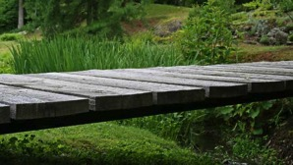
Question 5

Which types of internal forces should you think about most if you were building a bridge from wooden planks across a small creek?

Type your answer here.

Congratulations! You have completed this self-check quiz.

Now it's time to carefully compare your answers to the suggested answers in the online course. When comparing, you should feel free to make changes to your answers or make extra notes.

Don't forget to save the quiz whenever you make changes.

Keep this quiz for study purposes. If you want more feedback, share it with your teacher.

