Science 7
Unit D
Lesson 10
Self-Check Quiz

Answer all 5 questions in the spaces provided. Think carefully before typing your answers. If you need help, return to the lesson in the online course. Save your quiz when you are done.

Leave your answers in blue; it will be easier for you and your teacher to see them later.

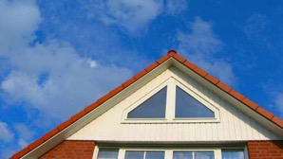
Question 1

Why is a triangular roof better in very snowy places than a flat roof is?

Type your answer here.


Question 2

This structure was built in the city of Jerusalem in 691 C.E. What structural component has helped this structure stand for so long? Explain your answer by describing forces and loads on the building.

Type your answer here.


Question 3

Why is this natural rock structure safe to stand on? Explain your answer by describing structural components and forces.

Type your answer here.

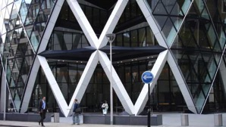
Question 4

This is a tower nicknamed "The Gherkin" in London, England. What structural components do you see that make this building strong? Explain your answer describing forces and loads on the building.

Type your answer here.

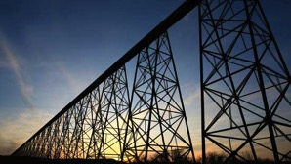
Question 5

Lethbridge, Alberta, is called the "Windy City". How does the design of this railroad bridge in Lethbridge help it remain standing in very strong winds?

Type your answer here.

Congratulations! You have completed this self-check quiz.

Now it's time to carefully compare your answers to the suggested answers in the online course. When comparing, you should feel free to make changes to your answers or make extra notes.

Don't forget to save the quiz whenever you make changes.

Keep this quiz for study purposes. If you want more feedback, share it with your teacher.

