Science 7
Unit D
Section 2
Self-Check Quiz

Answer all 5 questions in the spaces provided. Think carefully before typing your answers. If you need help, return to the lesson in the online course. Save your quiz when you are done.

Leave your answers in blue; it will be easier for you and your teacher to see them later.

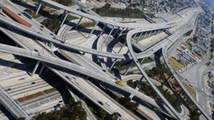
Question 1

Highway interchange bridges are used so that fast moving cars do not have to stop at traffic lights or stop signs when turning onto another road. What are the types of static loads that engineers must think about when designing highway interchange bridges?

Type your answer here.

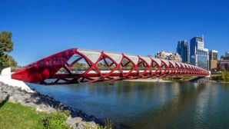
Question 2

Pedestrian bridges are narrow bridges that help people to walk or bicycle between places more quickly. What are the types of dynamic loads that engineers must consider when designing pedestrian bridges?

Type your answer here.

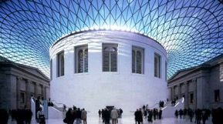
Question 3

This is the roof of the British Museum in London, England. What features of this glass roof make it sturdy?

Type your answer here.


Question 4

What type of force should you be most concerned about if you were choosing a new clothing rod for your closet?

Type your answer here.


Question 5

The Library of Parliament is at the rear of the Parliament Buildings in Ottawa. What features of this building make it strong?

Type your answer here.

Congratulations! You have completed this self-check quiz.

Now it's time to carefully compare your answers to the suggested answers in the online course. When comparing, you should feel free to make changes to your answers or make extra notes.

Don't forget to save the quiz whenever you make changes.

Keep this quiz for study purposes. If you want more feedback, share it with your teacher.

