Science 7
Unit D
Lesson 12
Self-Check Quiz

Answer all 5 questions in the spaces provided. Think carefully before typing your answers. If you need help, return to the lesson in the online course. Save your quiz when you are done.

Leave your answers in blue; it will be easier for you and your teacher to see them later.

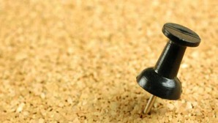
Question 1

Why would you choose staples or thumbtacks instead of glue to attach papers to a corkboard?

Type your answer here.


Question 2

On eyeglass frames, why is a movable joint better than a fixed joint?

Type your answer here.

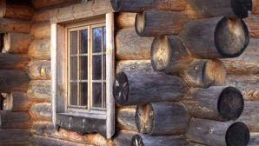
Question 3

Why are interlocking notches used instead of nails when constructing a log house?

Type your answer here.

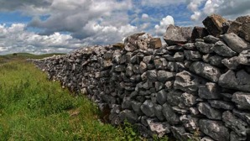
Question 4

Stone walls with no mortar are used in farm fields in the UK and Ireland. What keeps these walls standing? What is the advantage of making walls with no mortar?

Type your answer here.

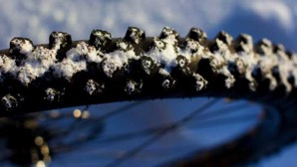
Question 5

Some people ride their bicycles during the winter. For safety, they use special bike tires with studs. Why?

Type your answer here.

Congratulations! You have completed this self-check quiz.

Now it's time to carefully compare your answers to the suggested answers in the online course. When comparing, you should feel free to make changes to your answers or make extra notes.

Don't forget to save the quiz whenever you make changes.

Keep this quiz for study purposes. If you want more feedback, share it with your teacher.

