Science 7
Unit D
Section 3
Self-Check Quiz

Answer all 5 questions in the spaces provided. Think carefully before typing your answers. If you need help, return to the lesson in the online course. Save your quiz when you are done.

Leave your answers in blue; it will be easier for you and your teacher to see them later.

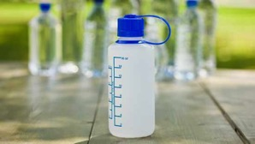
Question 1

A company is designing a reusable water bottle to sell in their stores. What are two important properties for the company to consider when choosing materials for the water bottle?

Type your answer here.

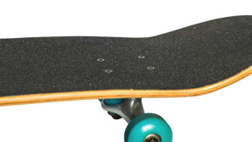
Question 2

What is one advantage of using laminated wood rather than pure wood in skateboards?

Type your answer here.

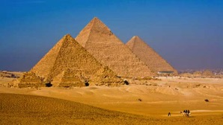
Question 3

Ancient Egyptian pyramids are made of bricks. The bricks are not cemented together with mortar. Explain how the pyramid bricks have stayed connected together for the last 4500 years.

Type your answer here.

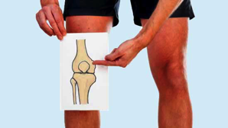
Question 4

Choose one type of mobile joint in the human body. Explain how it helps people do things in their normal lives.

Type your answer here.

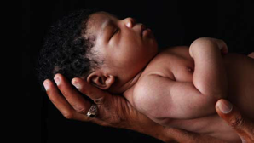
Question 5

Explain two ways that skin protects humans.

Type your answer here.

Congratulations! You have completed this self-check quiz.

Now it's time to carefully compare your answers to the suggested answers in the online course. When comparing, you should feel free to make changes to your answers or make extra notes.

Don't forget to save the quiz whenever you make changes.

Keep this quiz for study purposes. If you want more feedback, share it with your teacher.

