Science 7
Unit D
Lesson 15
Self-Check Quiz

Answer all 5 questions in the spaces provided. Think carefully before typing your answers. If you need help, return to the lesson in the online course. Save your quiz when you are done.

Leave your answers in blue; it will be easier for you and your teacher to see them later.

Question 1

What are two examples of safety designs used in cars?

Type your answer here.

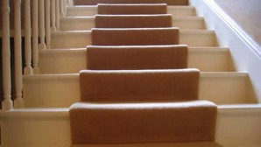
Question 2

Alberta's building code states that stairs in a house must be at least 235 mm deep and have a handrail. Explain why.

Type your answer here.

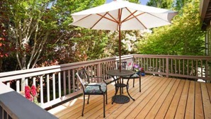
Question 3

Canadian building codes say that railings on an outside back deck cannot have spaces of more than 10 cm. Explain why.

Type your answer here.

Question 4

Canadian building codes say that schools must be designed with wide hallways and wide stairwells. Explain why.

Type your answer here.


Question 5

Why is wearing a helmet while skiing or snowboarding a good idea?

Type your answer here.

Congratulations! You have completed this self-check quiz.

Now it's time to carefully compare your answers to the suggested answers in the online course. When comparing, you should feel free to make changes to your answers or make extra notes.

Don't forget to save the quiz whenever you make changes.

Keep this quiz for study purposes. If you want more feedback, share it with your teacher.

