Science 7
Unit D
Lesson 17
Self-Check Quiz

Answer all 5 questions in the spaces provided. Think carefully before typing your answers. If you need help, return to the lesson in the online course. Save your quiz when you are done.

Leave your answers in blue; it will be easier for you and your teacher to see them later.

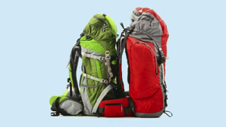
Question 1

Why do backpacks for overnight hiking trips have an aluminum rather than a wood frame to support the backpack?

Type your answer here.

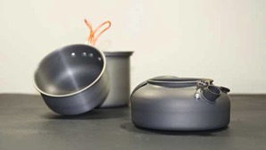
Question 2

Why might someone choose to take an aluminium pot rather than a stainless steel pot on an overnight backpacking trip?

Type your answer here.


Question 3

Why is woven material stronger than single fibres?

Type your answer here.


Question 4

Television sets used to be very deep – like big fat boxes. What has made possible this change in the design of television sets?

Type your answer here.

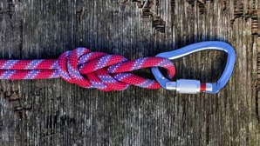
Question 5

Climbing ropes used to be made from natural materials. Why are modern climbing ropes made from nylon fibres rather than from a plant material?

Type your answer here.

Congratulations! You have completed this self-check quiz.

Now it's time to carefully compare your answers to the suggested answers in the online course. When comparing, you should feel free to make changes to your answers or make extra notes.

Don't forget to save the quiz whenever you make changes.

Keep this quiz for study purposes. If you want more feedback, share it with your teacher.

