Science 7
Unit D
Section 4
Self-Check Quiz

Answer all 5 questions in the spaces provided. Think carefully before typing your answers. If you need help, return to the lesson in the online course. Save your quiz when you are done.

Leave your answers in blue; it will be easier for you and your teacher to see them later.

Question 1

Explain two ways that a bike helmet is designed to keep people safe when they fall from their bikes.

Type your answer here.

Question 2

In what ways are wide hallways a safety feature in schools?

Type your answer here.

Question 3

Drinking cups are made from various materials. In what situation might you choose a plastic cup instead of a glass cup?

Type your answer here.

Question 4

Kitchen stoves and ovens used to be made of heavy cast iron. Old stoves and ovens were heated by burning wood. Modern stoves are made from steel, glass, and aluminium and use electricity or gas (natural gas or propane). What are two advantages of modern stoves?

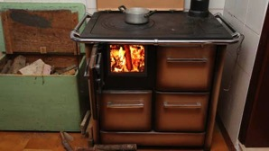



Type your answer here.


Question 5

Guitar strings used to be made from sheep or cow intestines (and were called catgut). Modern guitars have nylon or steel strings. What is the advantage of nylon or steel guitar strings compared to strings made from animal materials?
Type your answer here.

Congratulations! You have completed this self-check quiz.

Now it's time to carefully compare your answers to the suggested answers in the online course. When comparing, you should feel free to make changes to your answers or make extra notes.

Don't forget to save the quiz whenever you make changes.

Keep this quiz for study purposes. If you want more feedback, share it with your teacher.

